Alandalus Design

Database class project, academic year 2024 /2025

|  |  |  |  |  |
| --- | --- | --- | --- | --- |
| Student Name in English | Student Name in Arabic | Student ID | Section time as shown in zajel | Work percentage |
| Ghayda Adel Ramadan | غيداء عادل رمضان | 12216926 | 8:00-9:30 | 50% |
| Tala Ayman Alhendi | تالا ايمن الهندي | 12216912 | 8:00 - 9:30 | 50% |
|  |  |  |  |  |

Date/time

---------------------------------------------This section is intended for the Instructor---------------------------------------

|  |  |
| --- | --- |
| **Topic** | **Mark** |
| Project Requirements and Modeling |  |
| Correctness of Database mapping |  |
| Functional Dependency and Normalization |  |
| Project Tools |  |
| Project Discussion |  |
| Project Completeness |  |
| Project Output Results or reporting (JasperReport, charts, graphs, etc.) |  |
| Project Administration and Management |  |
| Project Report |  |
| Project Idea |  |
| Project Complexity |  |
| Team work |  |
|  |  |
|  |  |
|  |  |

# Abstract

This project involves developing an application for Alandalus Design Company, which prints custom products such as T-shirts, mugs, pins, and notebooks.

The application facilitates business operations, including order management, product tracking, and customer interactions, ensuring a streamlined workflow from design to delivery.

Key features include employee and customer management, product inventory tracking, and order processing with delivery integration. The system stores detailed records, supports database management, and provides secure user authentication. This report details the design, implementation, challenges, and solutions, demonstrating how the application supports Alandalus Design Company's commitment to quality and timely service.

# Table of Content

**● Abstract 2**

**● Table of Content 2**

**● Introduction 3**

**● Requirements Report 4**

**● Functional Dependency and BCNF 5**

**● Normalization 7**

**● EER Crow’s Foot Diagram and UML 8**

**● Tools 9**

**● GUI 10**

○ The Splash Screen 10

○ The Login Screen 11

○ The Dashboard interface 14

○ The Orders Page 20

○ The Customer Page 25

○ The Products Page 31

○ The Employee Page 35

○ The Manager Page 36

○ The Delivery Page 41

**● Conclusion 47**

**● References 49**

# Introduction

In today’s business environment, having an efficient management system is crucial for ensuring smooth operations. **Alandalus Design Company Application** was developed to help the company manage customer orders, track inventory, and monitor employee performance. The system is designed to simplify the company’s operations, covering everything from receiving orders to tracking their progress and ensuring they are delivered to the right company

The application encompasses key functionalities such as employee and customer management, product inventory tracking, order processing, and delivery integration. It also ensures secure user authentication, allowing different levels of access for employees and customers. By storing detailed records and supporting efficient database management, the application serves as a comprehensive tool for Alandalus Design Company to monitor and manage its operations effectively.

This report provides an in-depth exploration of the design and implementation process of the application. It outlines the challenges encountered during development and the solutions that were applied to overcome these obstacles. Ultimately, the application supports the company's commitment to providing high-quality products and ensuring timely service to its customers.

# Requirements Report

The company's data management system handles comprehensive records of employees, customers, products, orders, and delivery services. The following detailed requirements outline the key aspects of the system:

#### 1. Employee Data:

* **Attributes**: Each employee has a unique Employee ID, Employee Name, Username, Password, Job Position, Hire Date, Birth Date, Age, Working Hours, Salary, and contact information (including Email, Phone Number, and Address).
* **Functionality**:The Manager Controls the employee data management, including secure authentication using usernames and passwords. And each employee has only access to his/her information.

#### 2. Customer Data:

* **Attributes**: Each customer has a unique Customer ID, Customer Name, and contact information (Phone Number, Address, Email).
* **Functionality**: The system should store and manage customer details and link customers to their respective orders.

#### 3. Product Data:

* **Attributes**: Each product is recorded with a Product ID, Product Name, Category, Design, Unit Price, Stock Quantity, and Production Date.
* **Functionality**: The system should track product details, manage inventory levels, and associate products with orders.

#### 4. Orders and Order Details:

* **Attributes**: Orders have an Order ID, Order Date, Required Date, Status, and are linked to customers, delivery and employee-in-charge of this order. Order Details include the Quantity of products ordered.
* **Functionality**: The system should manage the lifecycle of an order, connect orders to products, customers, the employee who makes the sale and the Delivery Company who delivers the order. Also we keep track of product quantities for each order.

#### 5. Delivery Services:

* **Attributes**: Each delivery entity has a Delivery ID, Delivery Name, and contact information (Phone Number, Address, Email).
* **Functionality**: The system should facilitate the association of delivery services with orders, ensuring that delivery information is tracked and managed effectively.

#### 

#### 6. Relationships:

* **Employee-Orders**: Employees are linked to orders, representing who processed each order.
* **Customer-Orders**: Each order is associated with a specific customer.
* **Orders-Delivery**: Orders are connected to delivery services for tracking purposes.
* **Product-Order Details-Order**: The Order Details entity bridges products and orders, specifying product quantities in each order.

#### 7. General Contact Information:

* The system maintains contact records for employees, customers, and delivery services, including their Phone Number, Address, and Email.

### Key Functional Requirements:

* **Data Management**: Create, read, update, and delete (CRUD) operations for employees, customers, products, orders, and delivery information.
* **Authentication**: Ensure secure access for employees through a username and password system.
* **Order Tracking**: Link orders to customers and delivery services to manage the status and logistics of each order.
* **Product Inventory**: Maintain an updated inventory of products and monitor stock quantities.
* **Reporting**: Generate reports that provide insights into customer orders, employee activities, product stock, and the order details.

# Functional Dependency and BCNF

1. **Customer**

Customer_ID → Customer_Name   
Customer_ID → Address  
Customer_ID → Email  
Customer_ID → Phone_Number

1. **Employee**

Employee ID → Employee Name  
Employee ID → Birth Date  
Employee ID → Salary  
Employee ID → Email  
Employee ID → User Name  
Employee ID → Password  
Employee ID → Address  
Employee ID → Phone Number  
Employee ID → Job Position  
Employee ID → Hire Date  
Employee ID → Working Hours

1. **Delivery**

Delivery ID → Delivery Name  
Delivery ID → Address  
Delivery ID → Email  
Delivery ID → Phone Number

1. **Product**

Product ID → Product Name  
Product ID → Design  
Product ID → Product Date  
Product ID → Category  
Product ID → Unit Price  
Product ID → Stock Quantity

1. **Orders**

Order_ID → Order_Date  
Order_ID → FK CustomerID  
Order_ID → Status  
Order_ID → FK DeliveryID  
Order_ID → FK EmployeeID  
Order_ID → Delivering Date  
Order_ID → Required_Date

1. **Order details**

FK OrderID,FK ProductID → Quantity

# Normalization

**All tables are in:**

**First normal form (1NF):** There is no multivalued attribute. **Second normal form (2NF):** The only table with a composite key is the Order details table, which can be used to access all related values.   
**Third normal form (3NF):** No non-primary-key column is transitively dependent on the primary key.   
**Boyce-Codd normal form (BCNF):** Every determinant is a candidate key

# EER Crow’s Foot Diagram and UML

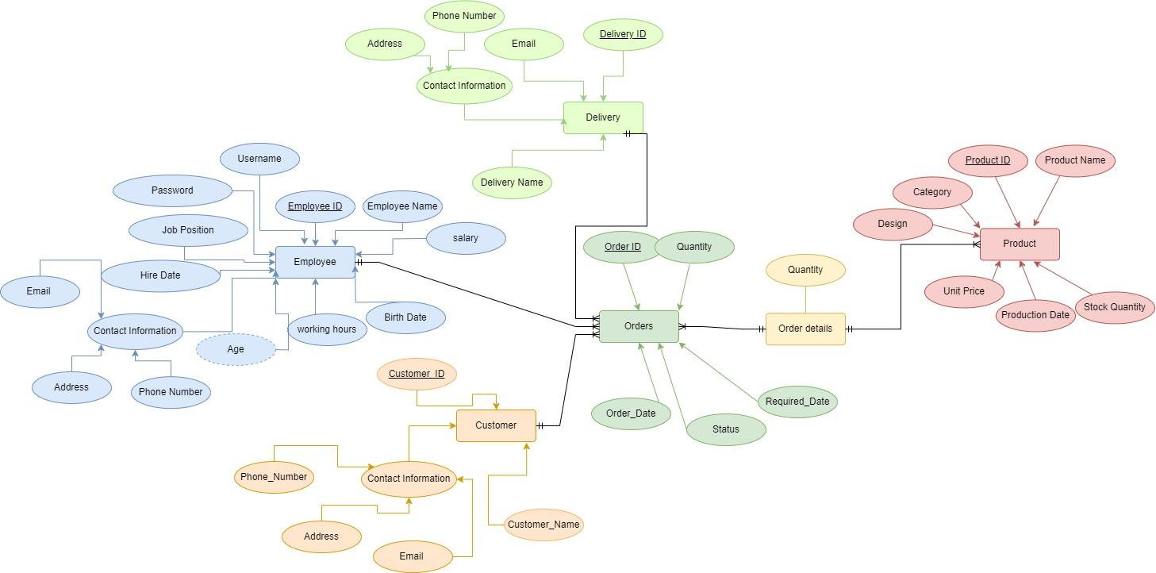

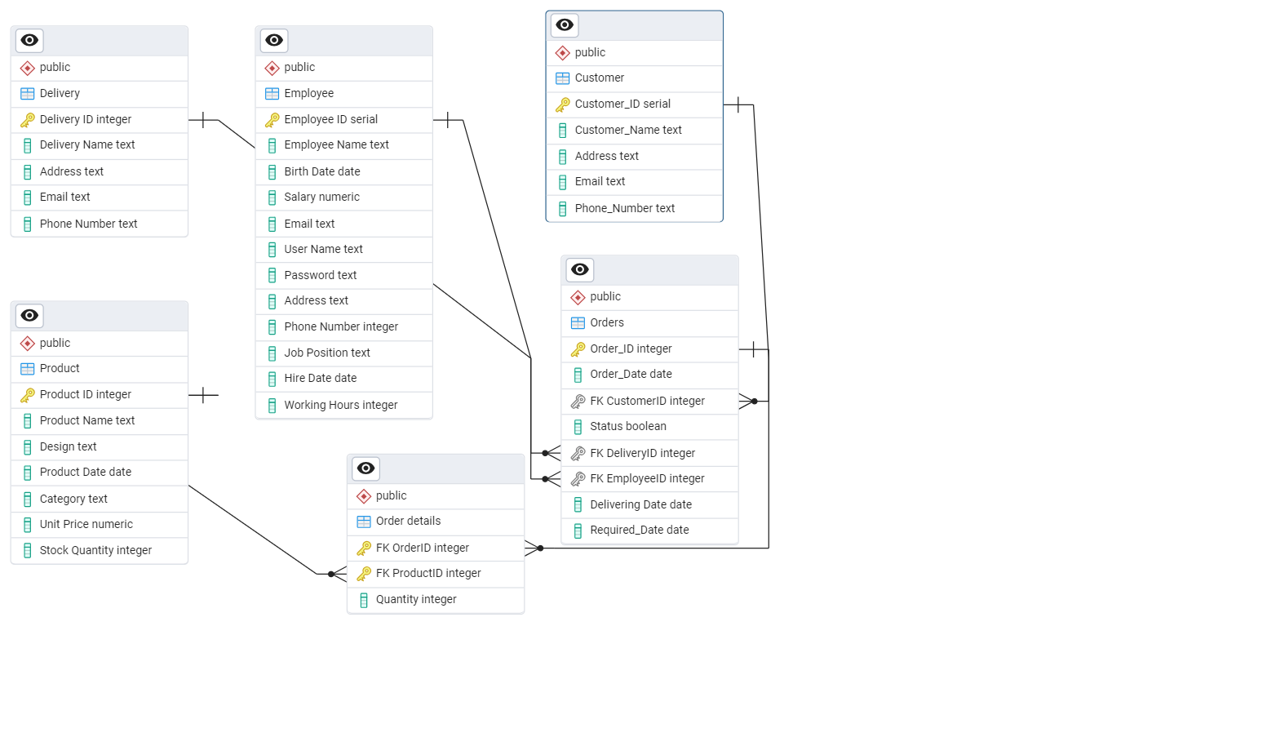

# Tools

* **IntelliJ IDEA**  
  was used as the main development environment, integrating JavaFX, Maven, and the database for efficient management and development.
* **Scene builder**Design the user interface, creating an intuitive and responsive layout for the application with JavaFX.
* **jaspersoft Studio**Design and generate custom reports, providing detailed insights into the company's operations.
* **PgAdmin**Manage and administer the PostgreSQL database, allowing for efficient data storage, retrieval, and organization.

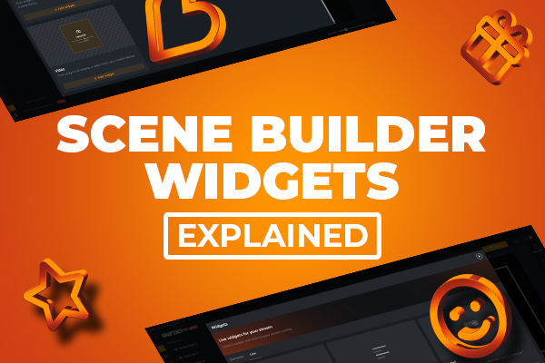



# GUI

## The Splash Screen

The splash screen features a typing animation that reveals the company name letter by letter, along with a typing sound effect. Once completed, it smoothly transitions to the login screen, creating a polished and engaging way to start the application.

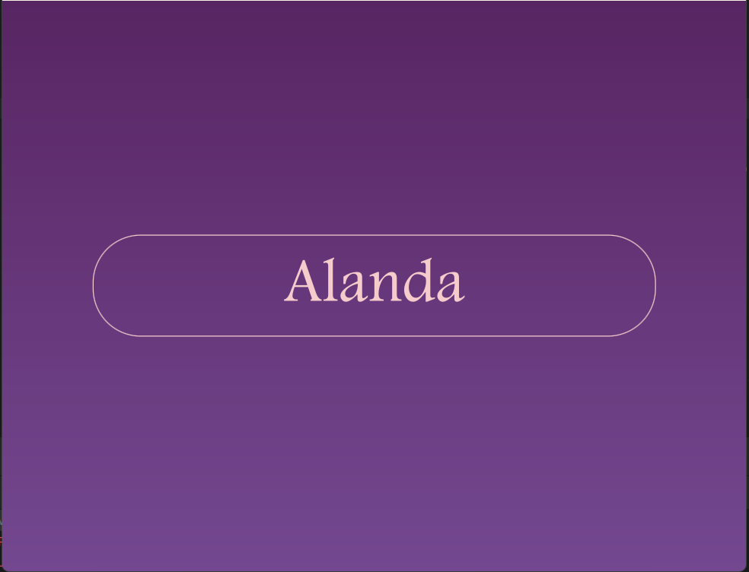

## The Login Screen

The User Login Screen includes text fields for username and password, a Login button, and a QR code linking to the company’s social media accounts.

It provides secure authentication, allowing users to enter their credentials in dedicated fields for username and password. After entering these details, users can either press "Enter" or click the Login button to attempt access. If the credentials are correct, they are granted access to the application

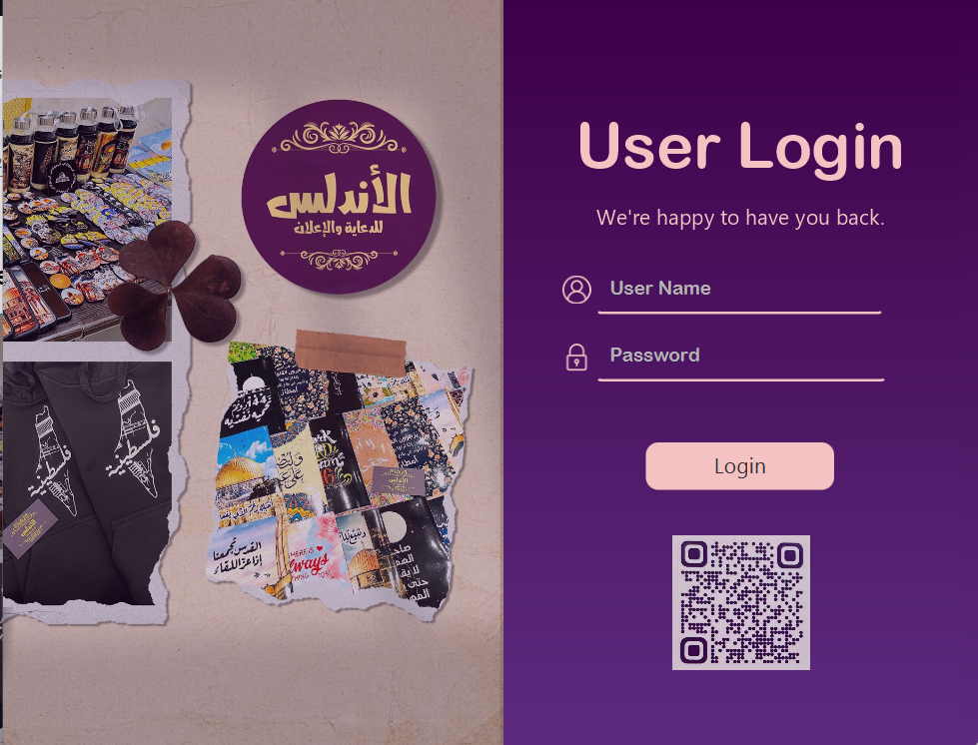

If the user presses Enter or clicks the Login button without entering a username or password, a red error message will appear as a prompt.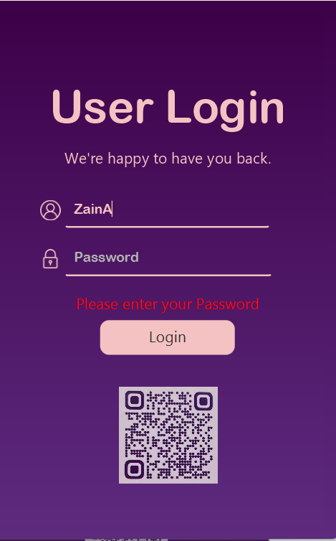

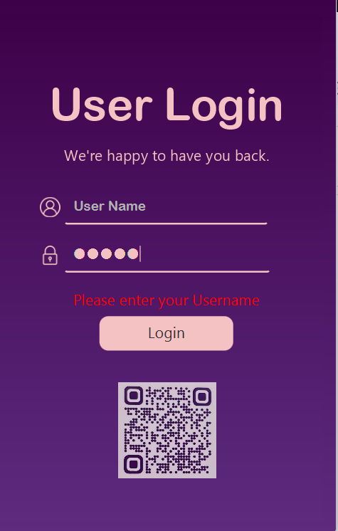

If the user enters an incorrect username or password, a "Login failed" message will appear.

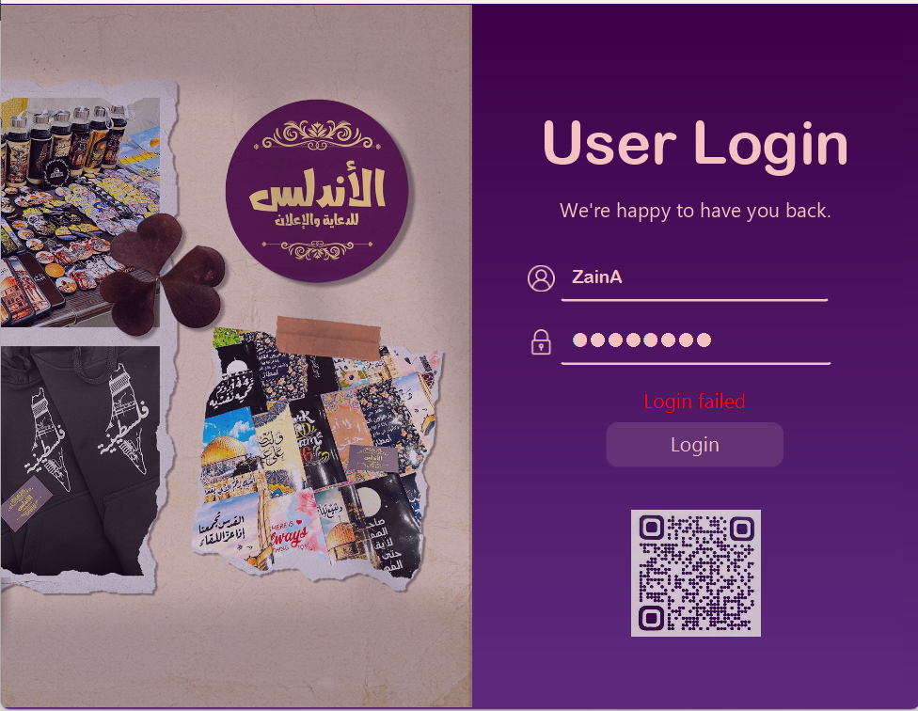

Upon login, the system identifies the user’s **role** as either an **employee or a manager.** This role-specific **authentication** customizes the experience by directing users to interfaces tailored to their position, ensuring that employees and managers have appropriate access to the features they need.

Since employees are added directly through the manager's interface, there is no need for a signup page.

## The Dashboard Page

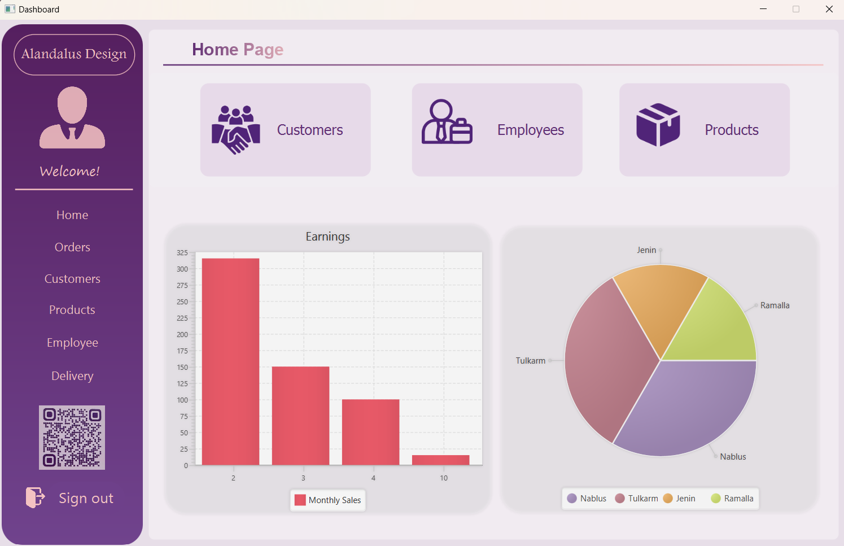

After a successful login, the Home Page is displayed. This page provides a summary of key company sections, such as Customers, Employees, and Products, which are represented by the three anchor panes above. When the user clicks on any of these sections, a Jasper report for the respective section is generated and displayed.

* Customer  
  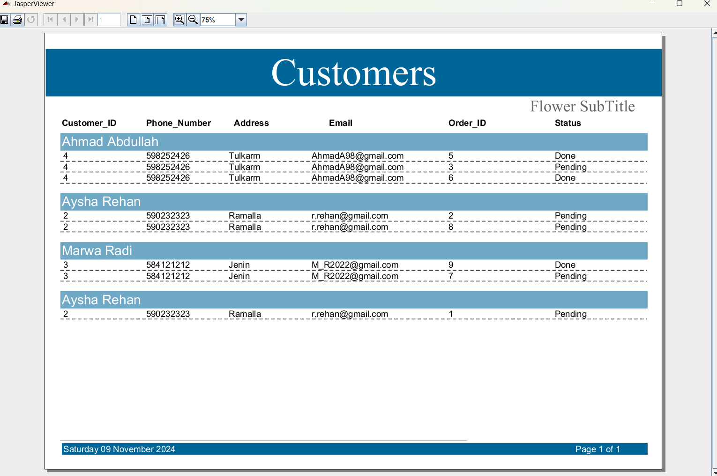

This report displays a list of all customers along with their respective orders, including the status of each order (pending or completed).

* 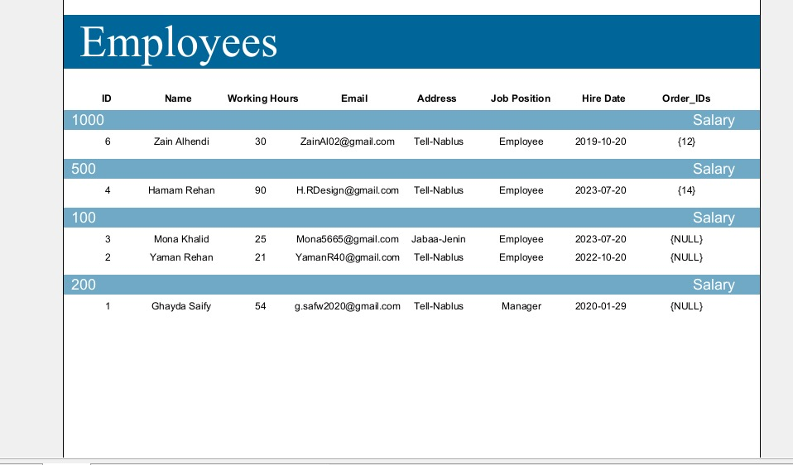Employee

This report displays a list of all employees and the orders they have made, sorted by each employee's salary in descending order. It also provides detailed information about each employee.

* Product 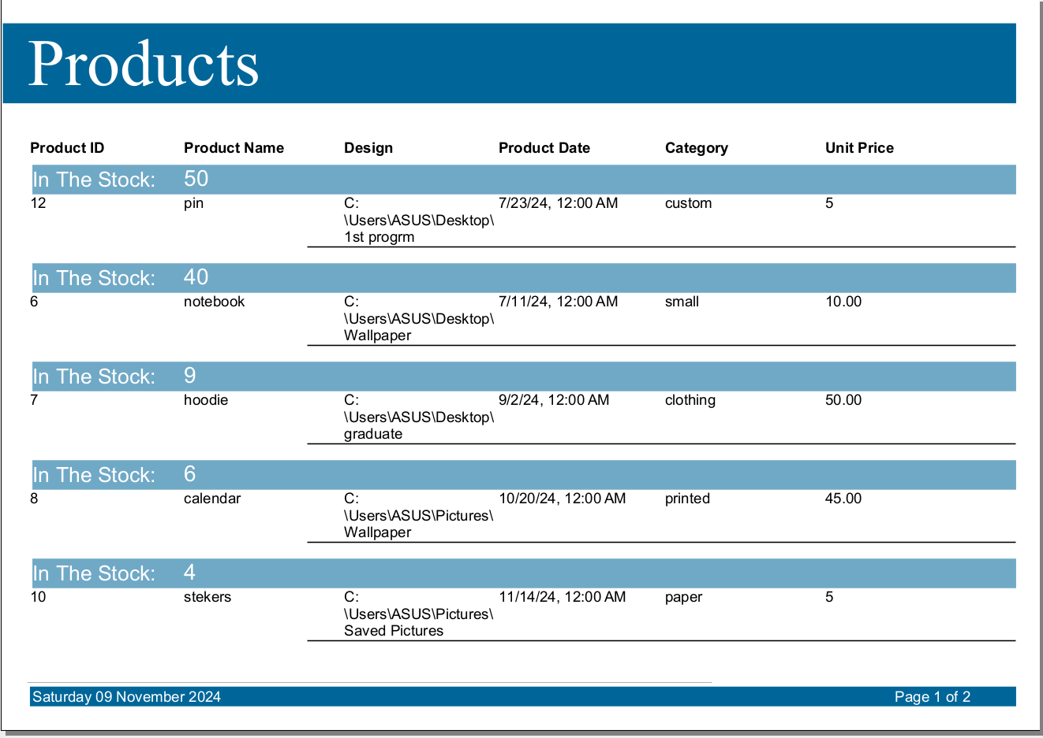

This report displays all the products offered by the company, along with the quantity of each product in stock.

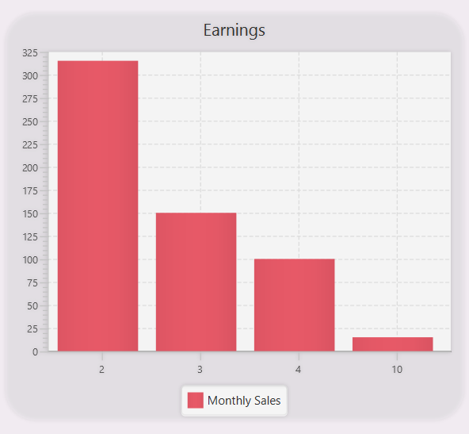

Below these three panes, two charts are displayed. The first is a bar chart that represents the company's earnings over the past year.

The second is a pie chart that illustrates the distribution of customers across the country, showing the number of customers in each city.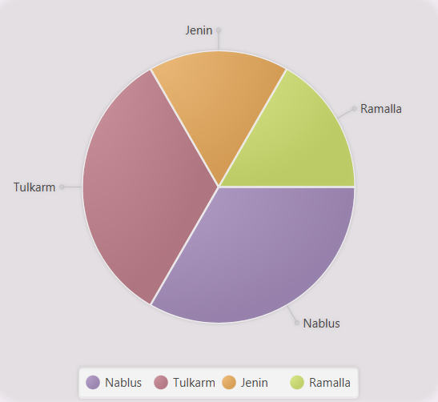

On the left side, we have the menu bar, starting with the company logo, 'Alandalus Design.' Below the logo, the main sections of the application are listed, including Home, Orders, Customers, 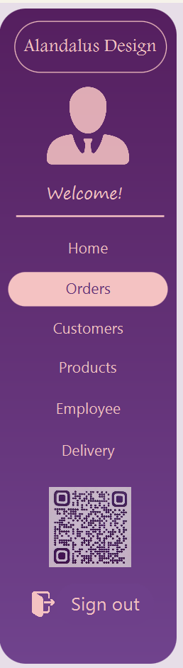

Products, Employees, and Delivery. At the bottom, there is a Sign Out button, which returns the user to the login screen.

We utilized complex functions to generate the charts and added additional features to enhance the user experience. For instance, when the user clicks on any part of the customer pane, the corresponding Jasper report opens immediately, allowing the user to track all relevant information seamlessly. The same functionality applies to the Employee and Product panes.

Our focus was on creating a simple, user-friendly interface, while also incorporating a vibrant color gradient to enhance the application's visual appeal. We ensured that the chart colors align with the overall style of the app for consistency.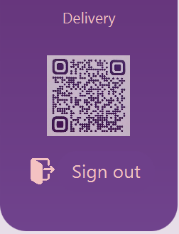

Lastly, we included a QR code linking to the company's social media pages, allowing users to easily access them with a single scan.

## 

## The Orders Page

On the orders page, we show all the order information stored in the database. It includes features like a search filter, a list of orders, and form fields for order details with options to update, add, clear, and delete orders. Additionally, there's a checkbox to filter for unfinished orders. The **Clear** button resets all form fields, allowing the user to start fresh if they want to enter new data or cancel the current input.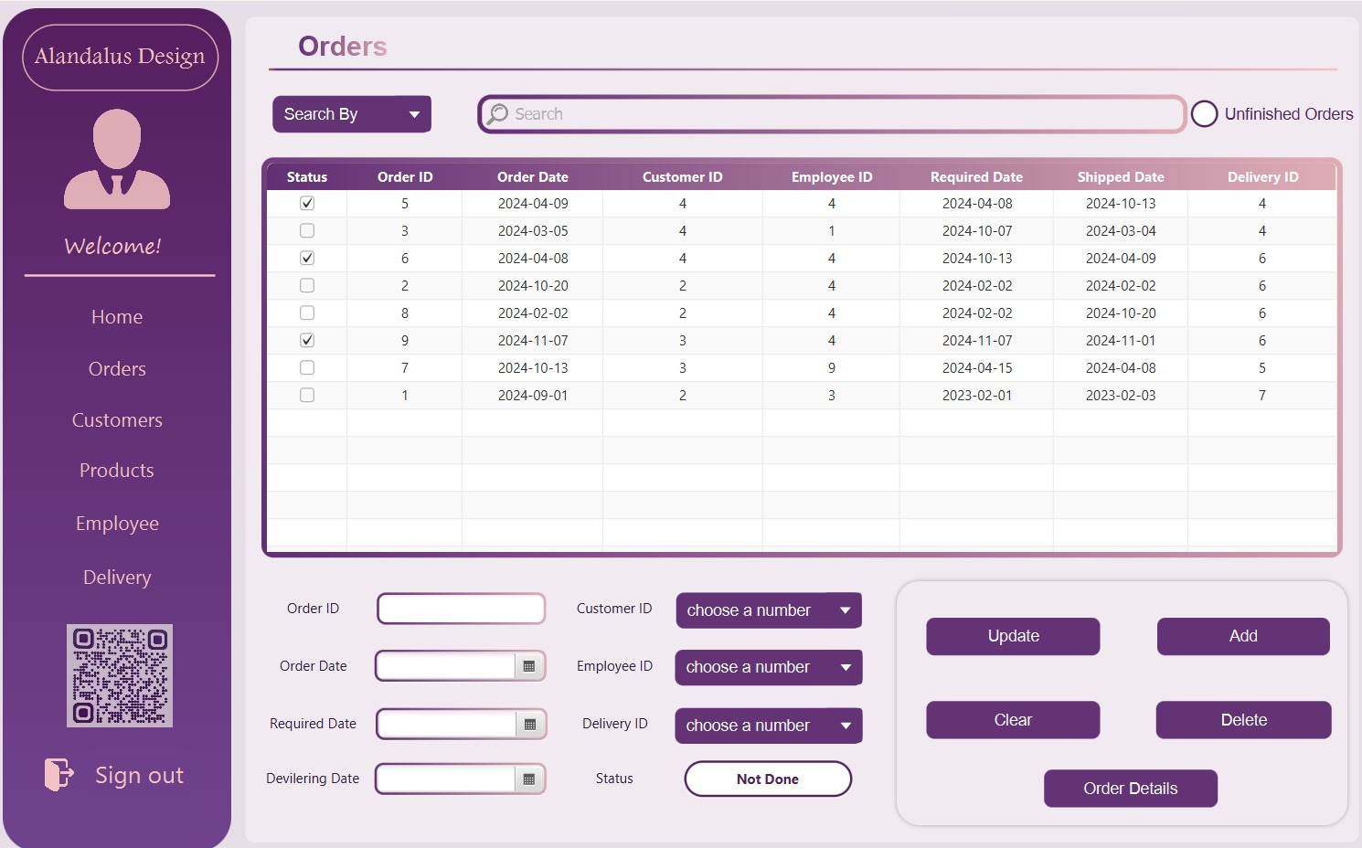

To prevent the possibility of entering incorrect IDs that don't exist, the process of entering customer ID, employee ID, and delivery ID is handled through a combo box. Each combo box contains a list of valid IDs, ensuring that the user selects an existing ID from the available options. This eliminates the risk of manual entry errors and ensures accurate record-keeping.

If you click on a field in the database table view, all the information will appear in the text field.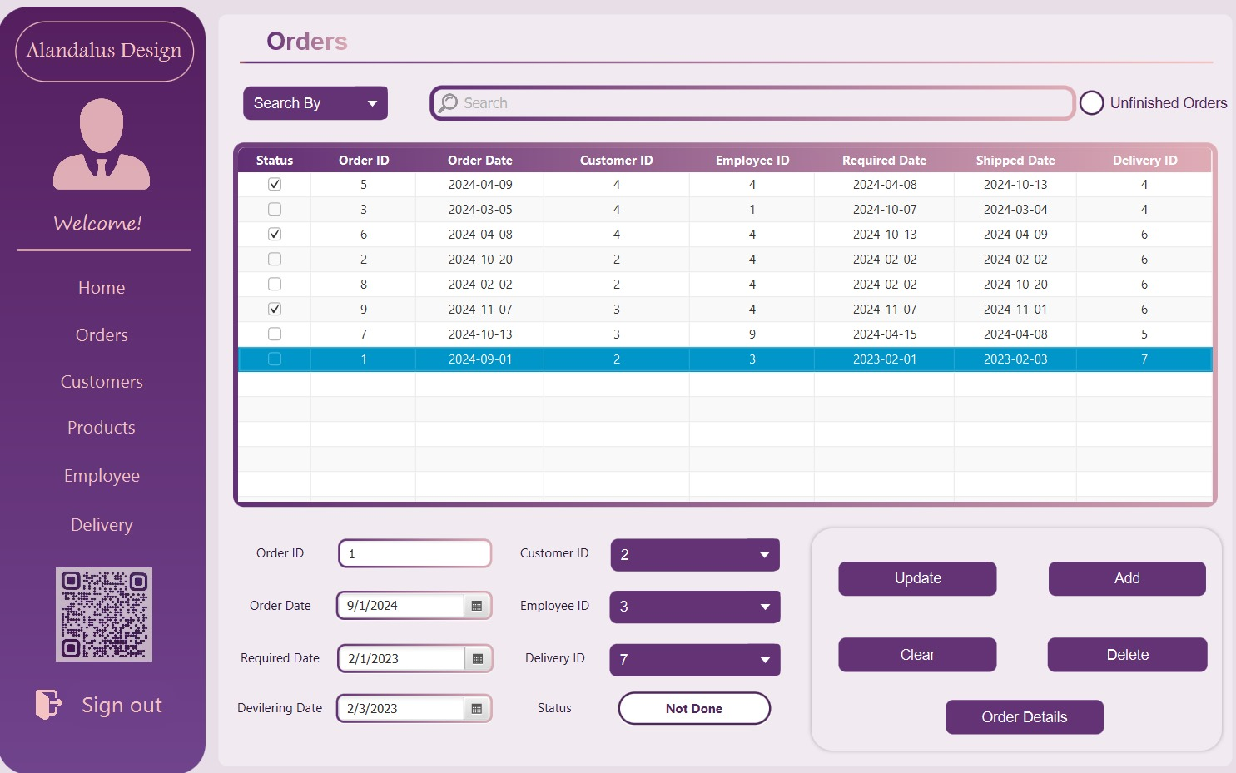

By selecting the "**Unfinished Orders**" checkbox, you can view all pending orders.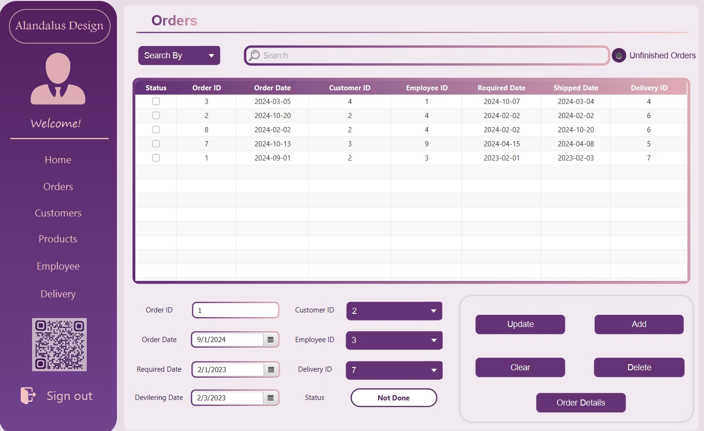

You can add new orders by entering all the required information. The order ID is set to a default value, and you can select the IDs for the employee, customer, and delivery.  
The **search section** allows users to find specific orders by filtering through different criteria. Next to the dropdown menu is a **search bar** where users can enter a value based on the selected criteria to find matching orders.You can **Update** or **delete** the field you want.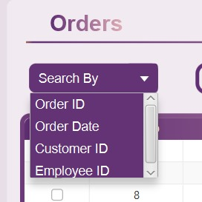

To make it easier for the employee and enhance their interaction with the application, the employee can simply press Enter once the information is updated, and the data will be immediately refreshed.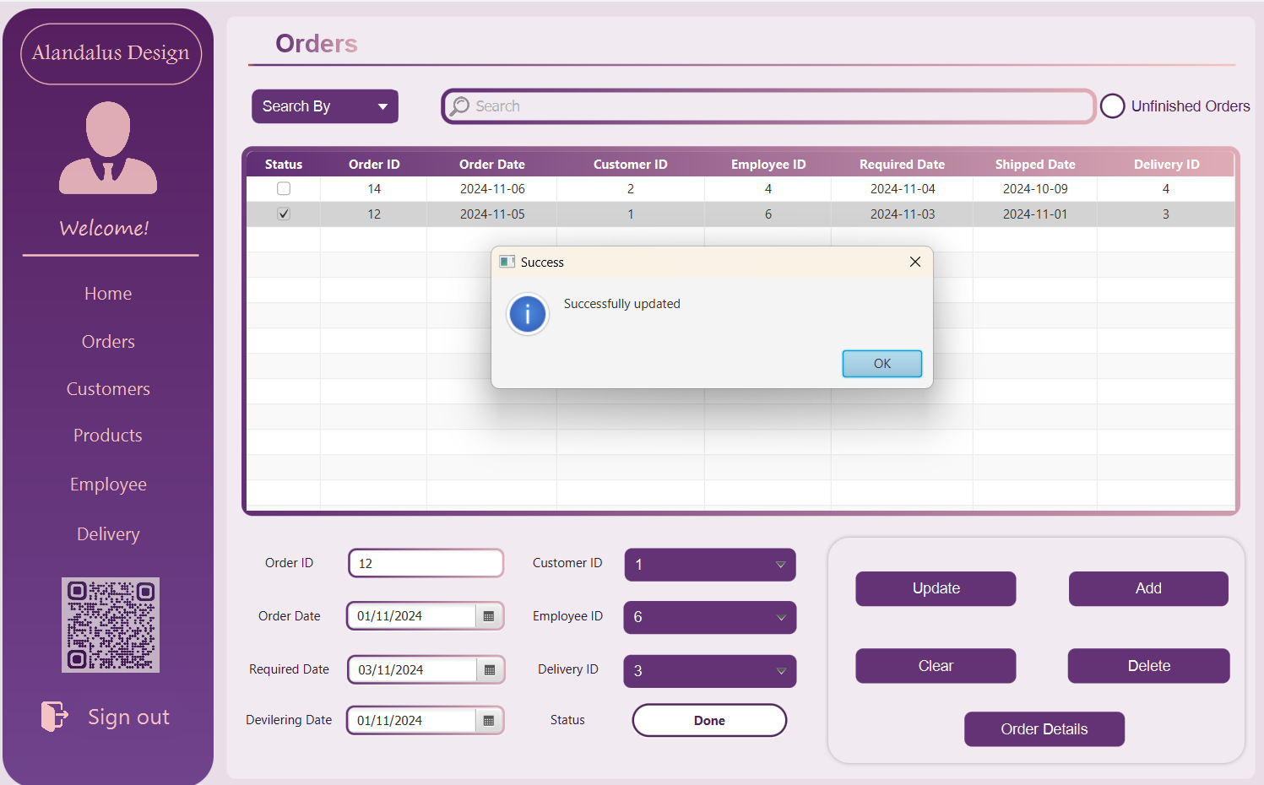

If you press Enter or click the button with the mouse, it will execute the function associated with that button. This behavior ensures that the user can interact with the system in a seamless way, whether using the keyboard or the mouse, providing flexibility and convenience in performing tasks.This feature available for all pages.

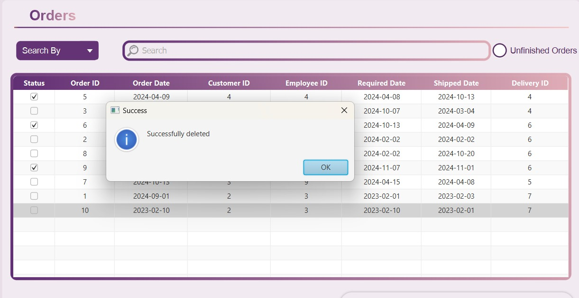

When you click the "Order Details" button, the Jasper report will appear.

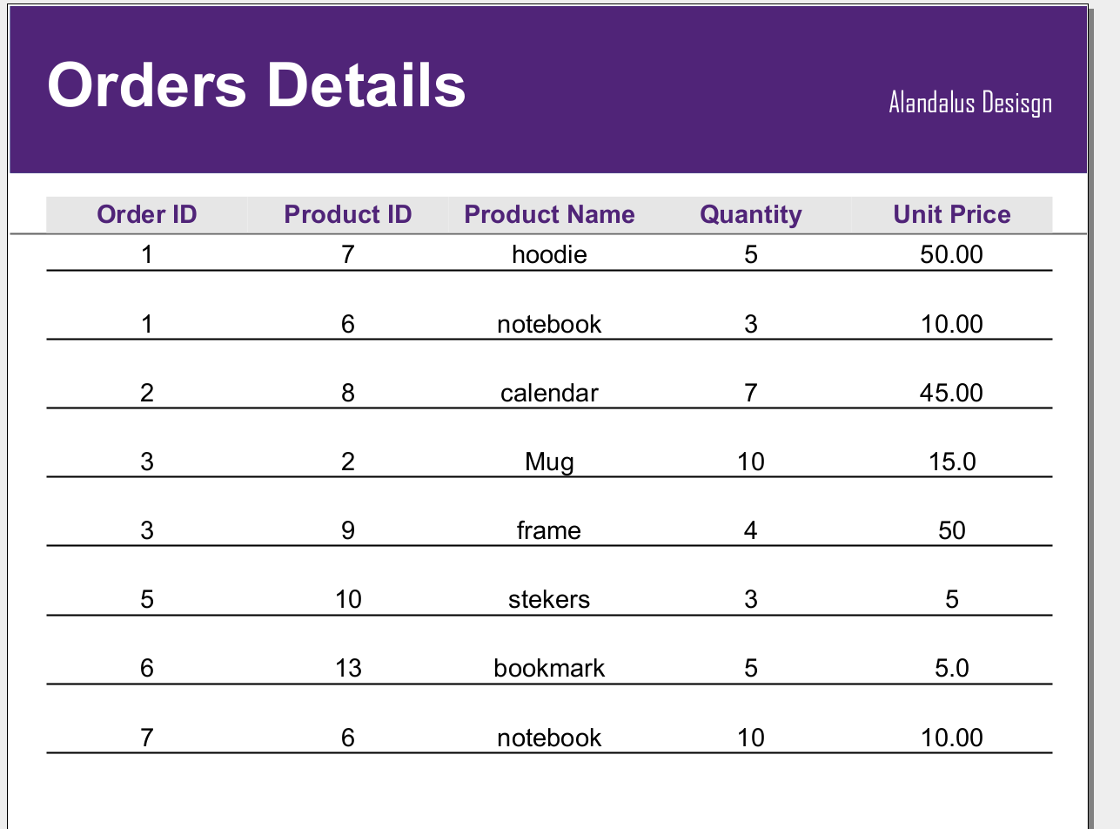

If the employee attempts to **add** an ID for the order, an error message will be displayed, indicating that the order ID cannot be manually entered.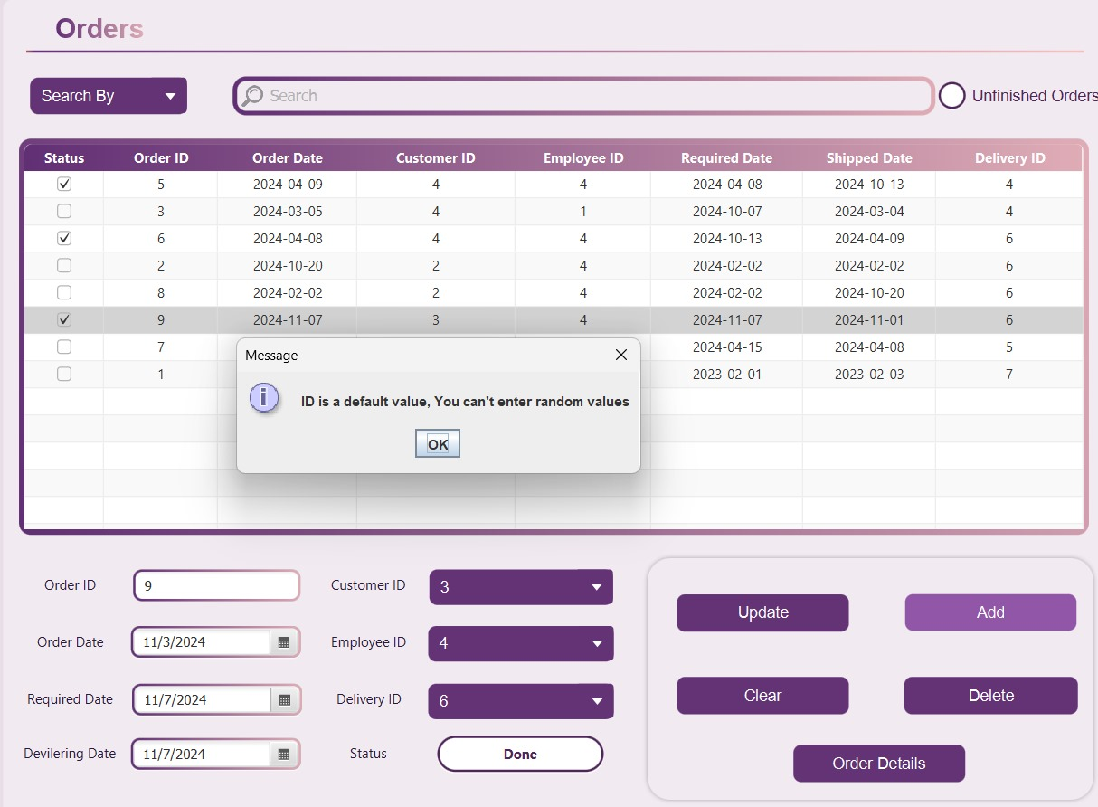

If the employee attempts to **update** an ID that doesn't exist, an error message will be displayed, indicating that the ID is invalid or not found in the system.

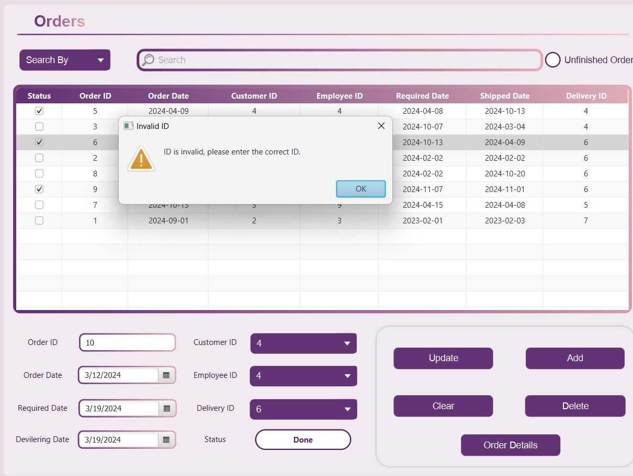

## The Customer Page

On the Customers page, all customer information stored in the database is displayed. The page includes a search filter that allows users to search by customer ID, name, or address. Additionally, a table of customers is presented, with options to update, add, clear, or delete customer information. The Clear button resets all form fields, enabling the user to start fresh if they wish to enter new data or cancel the current input.

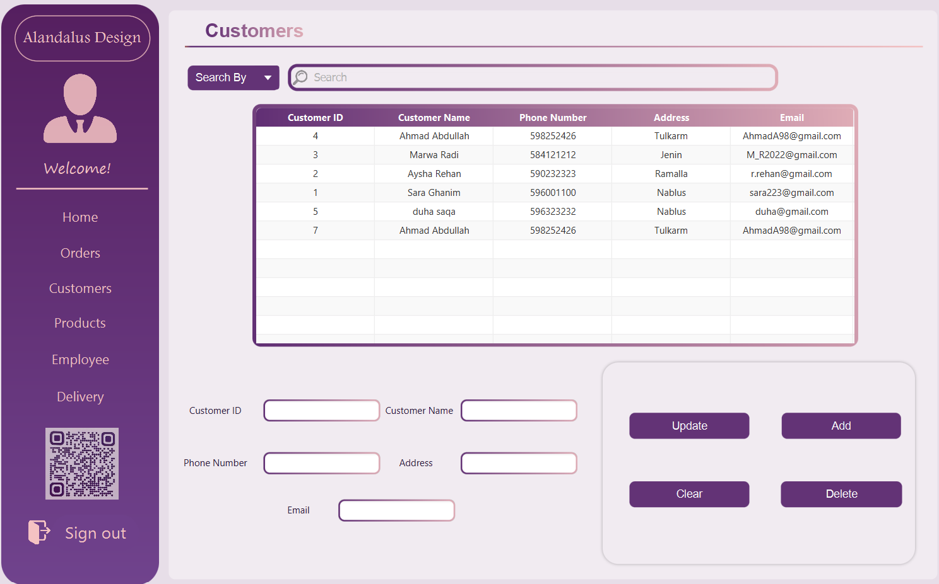

When the user clicks on any row in the table, all the data from that row is populated into the text fields below the table.

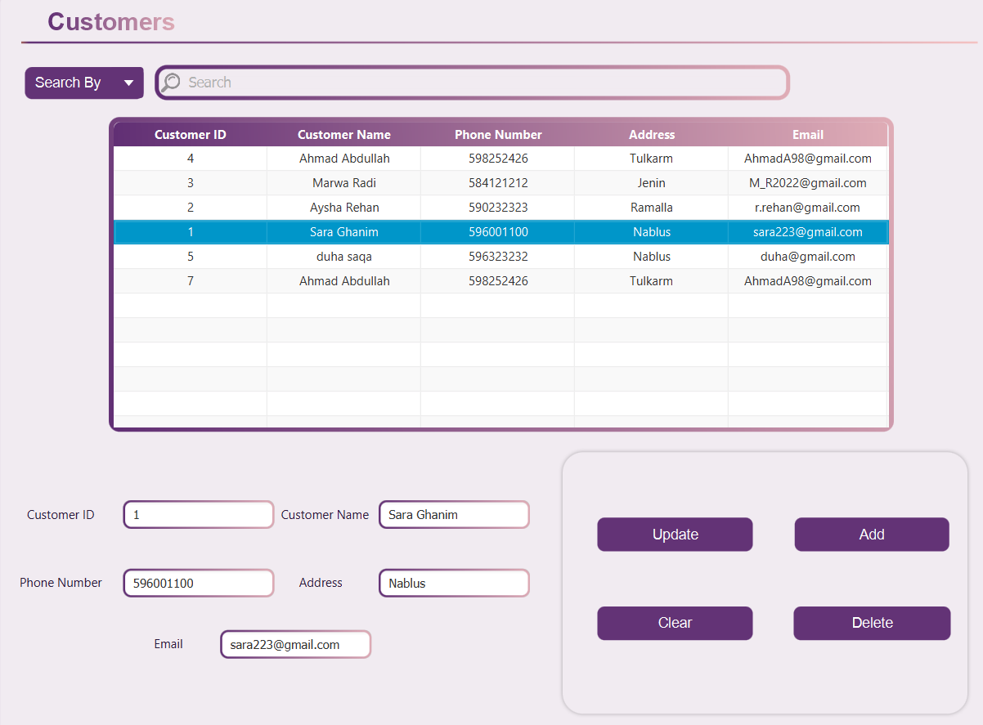

The user has the option to modify the data or delete the row as needed. If the user wants to search for specific information, they can choose to search by customer ID, name, or address. They simply need to enter the relevant information into the search box and press Enter. To view all the data again, the user can clear the search box and press Enter.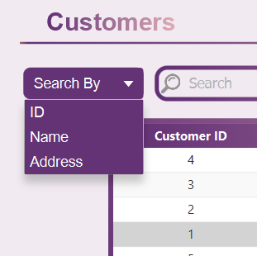

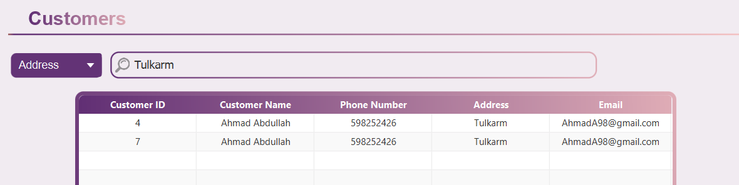

Then deletes the word “Tulkarm” and press Enter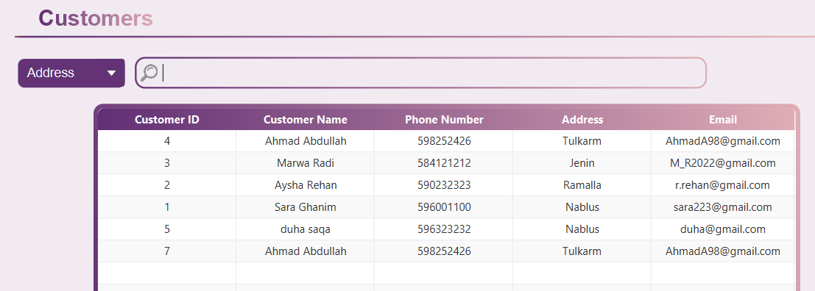

All the buttons (add, update, delete, clear) are the same as Orders page :

Add :

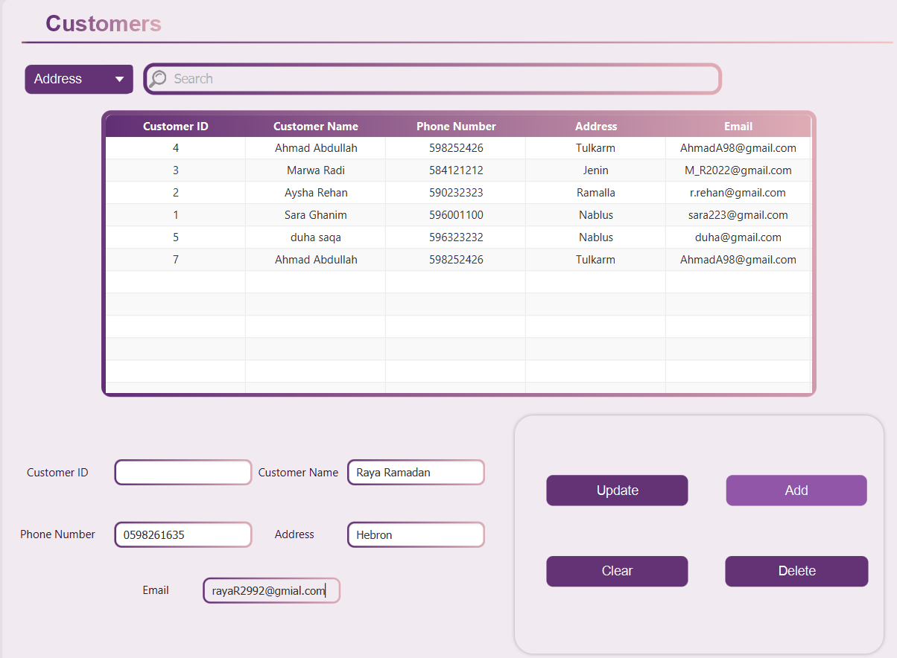

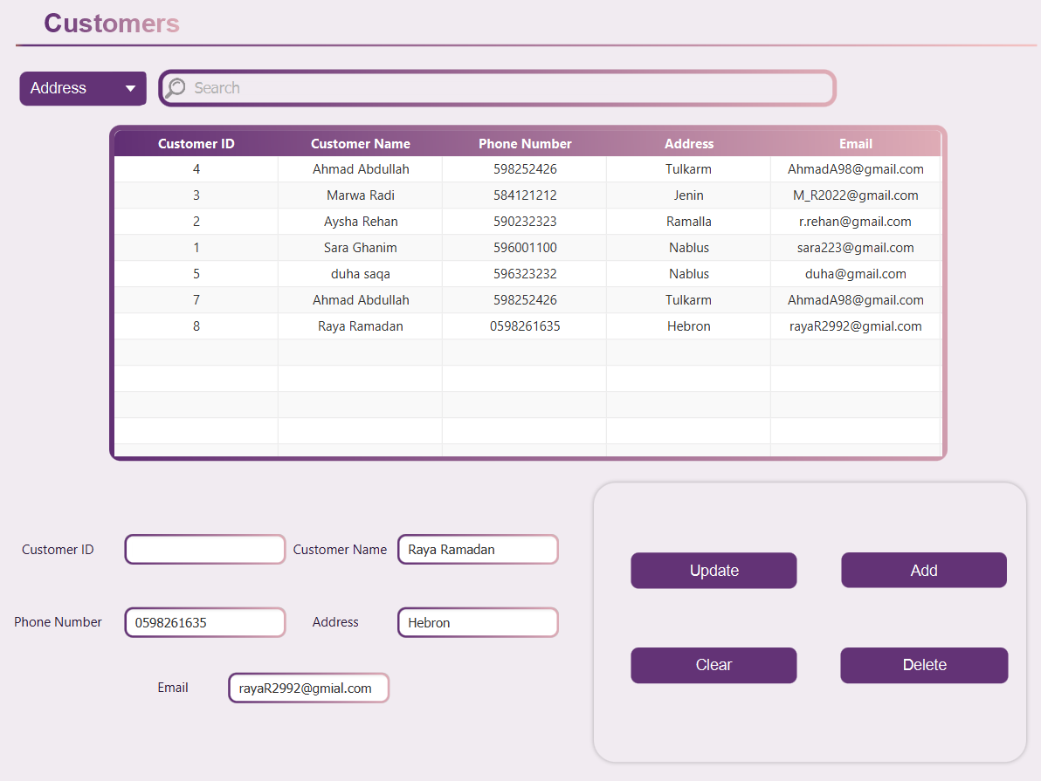

And if the user forgot any field : 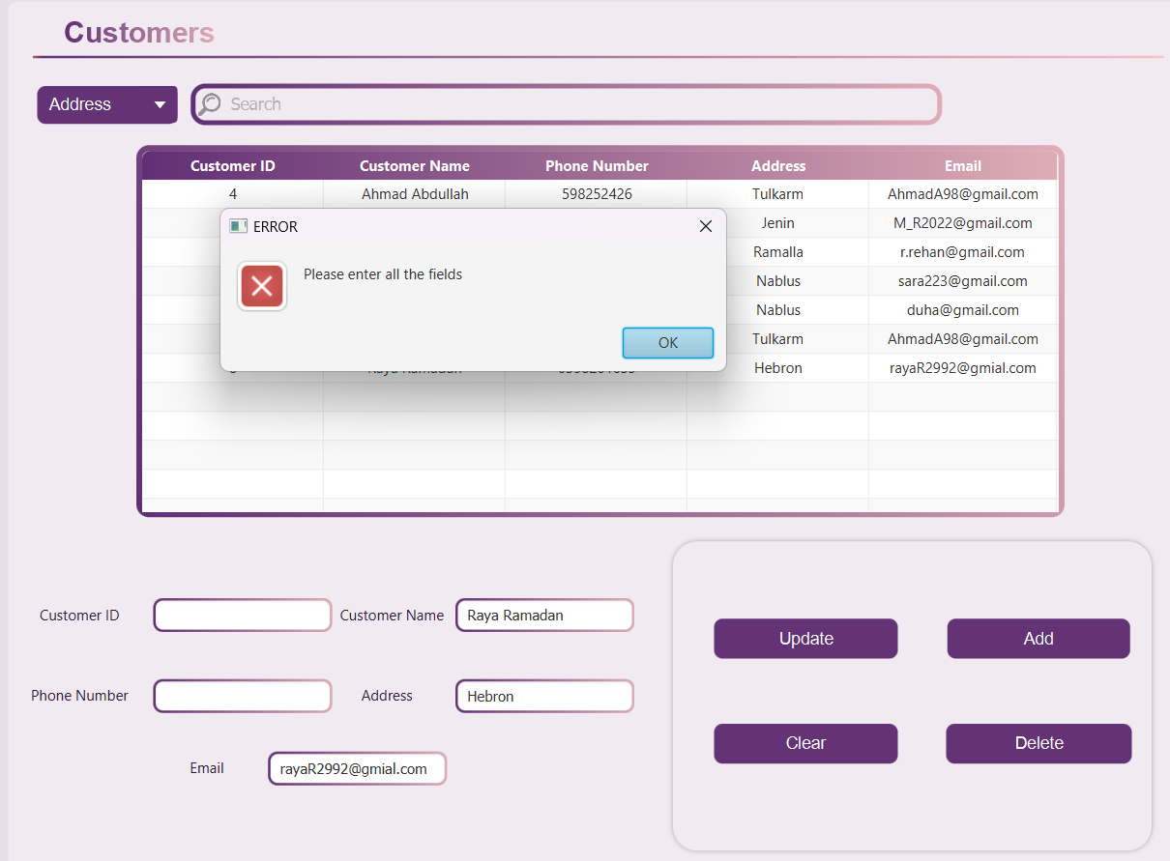

**Update :** 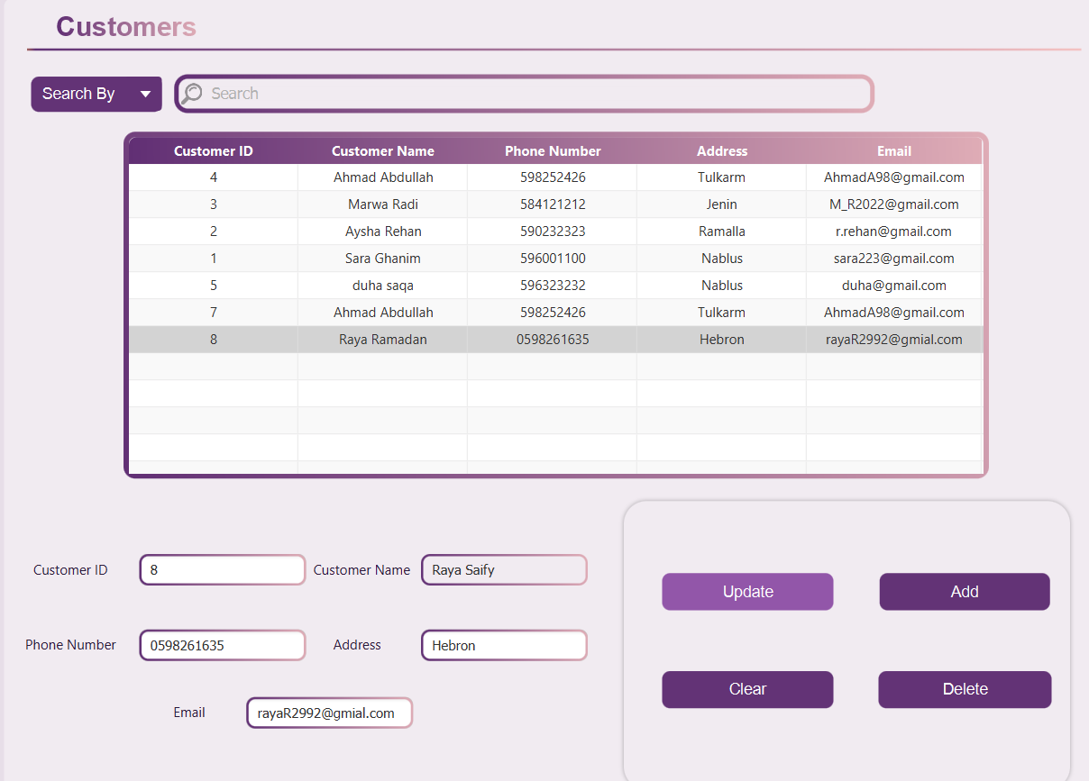

**delete :** 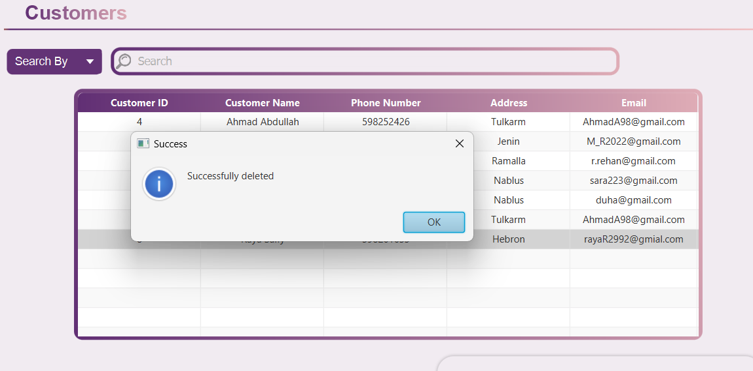

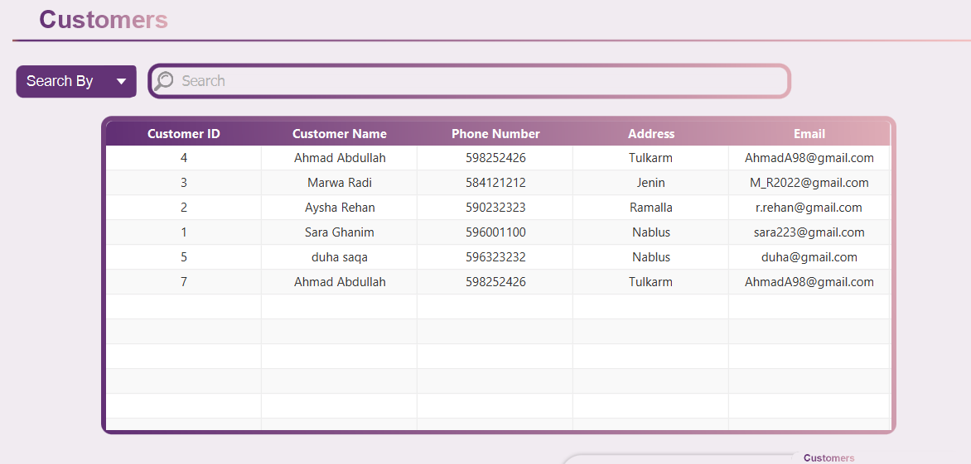

## The Products Page

On the products page, we display all the product information stored in the database. It includes features such as a search filter, a list of products, and form fields for product details with options to update, add, clear, and delete products. The **Clear** button resets all form fields, allowing the user to start fresh if they wish to enter new data or cancel the current input.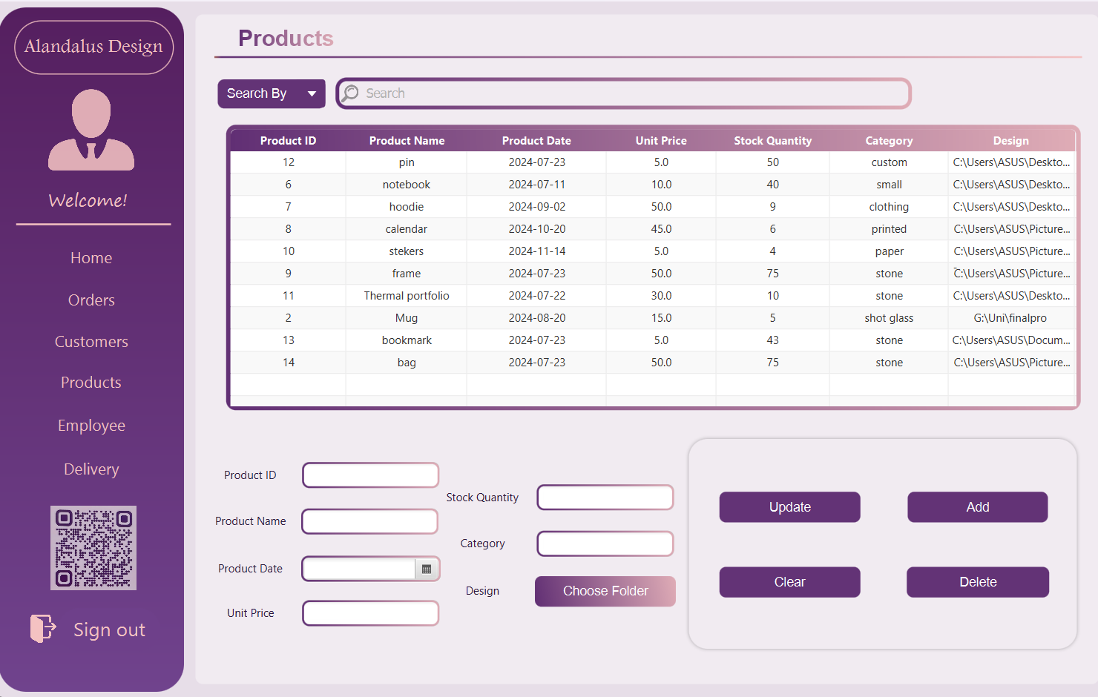

you can **Add**, **Update** and **Delete**.

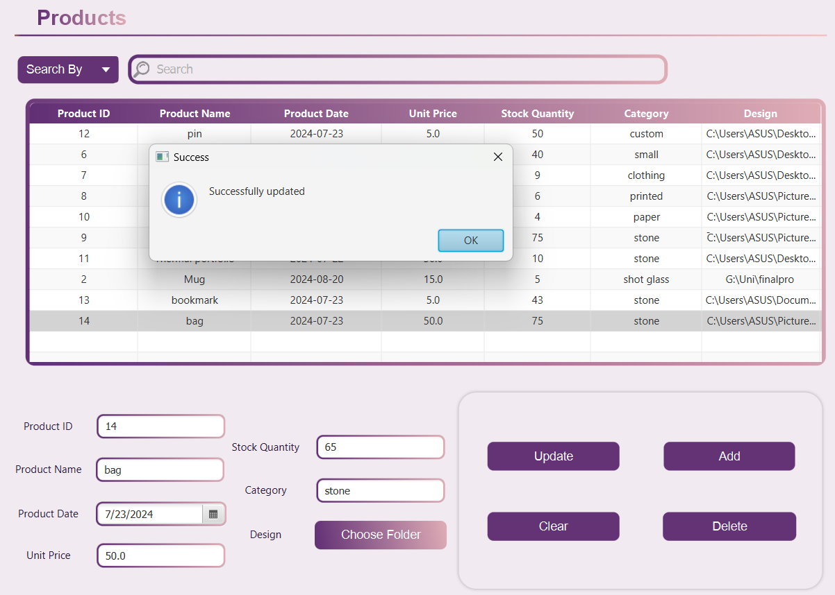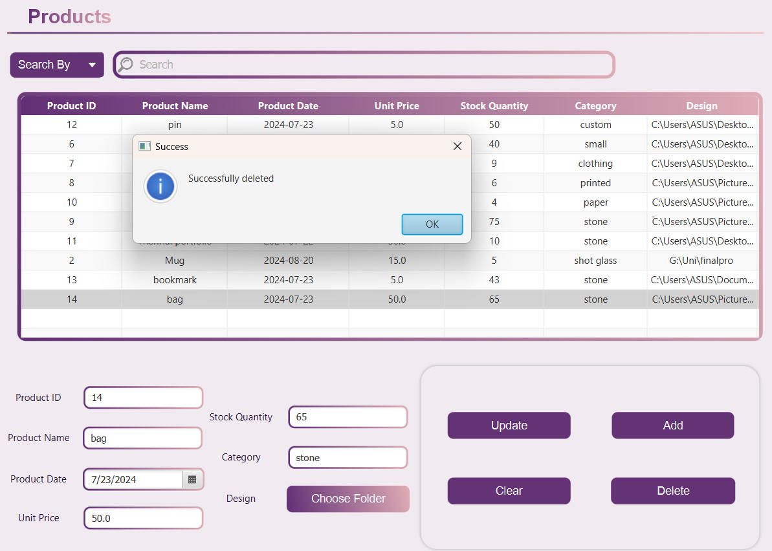

You can search too.

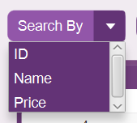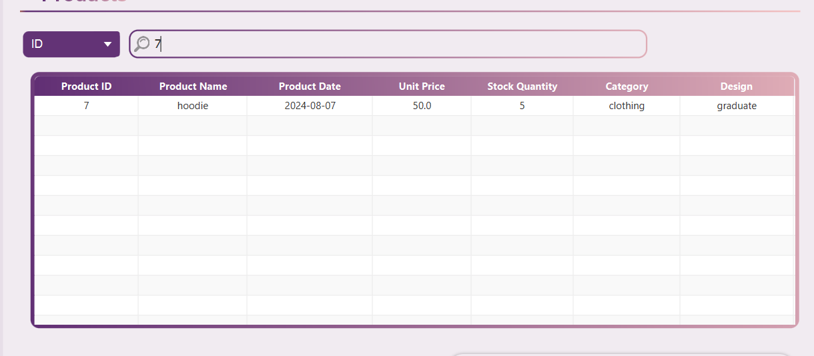

last feature is the design attribute, the employee can choose a folder contains all the designs for the specific product that they trying to add :

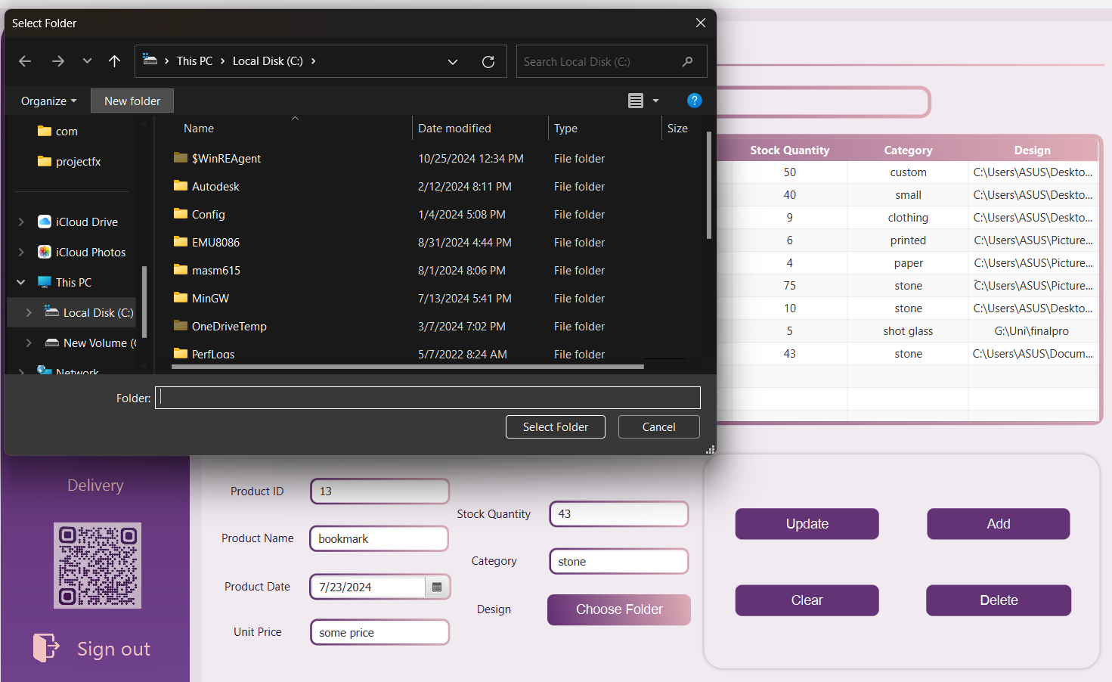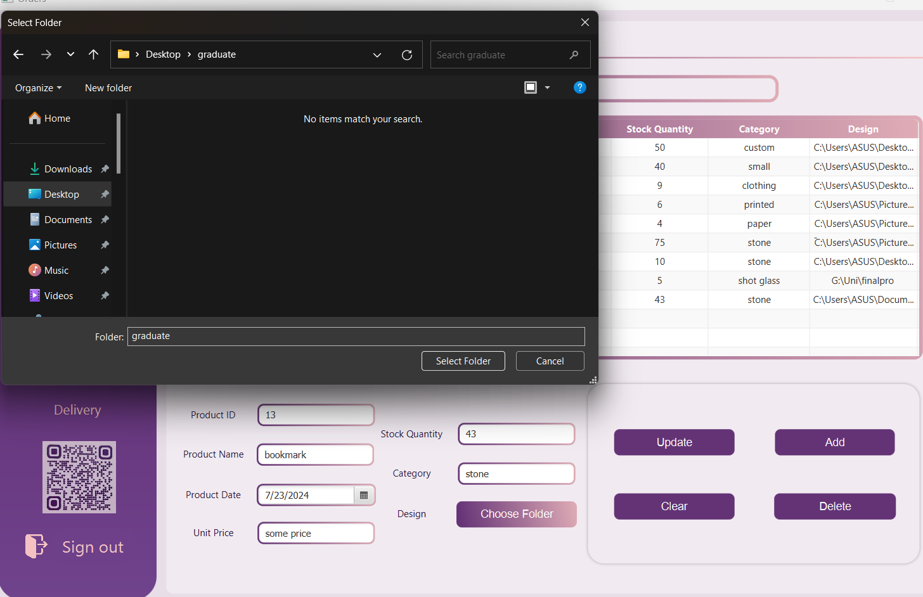

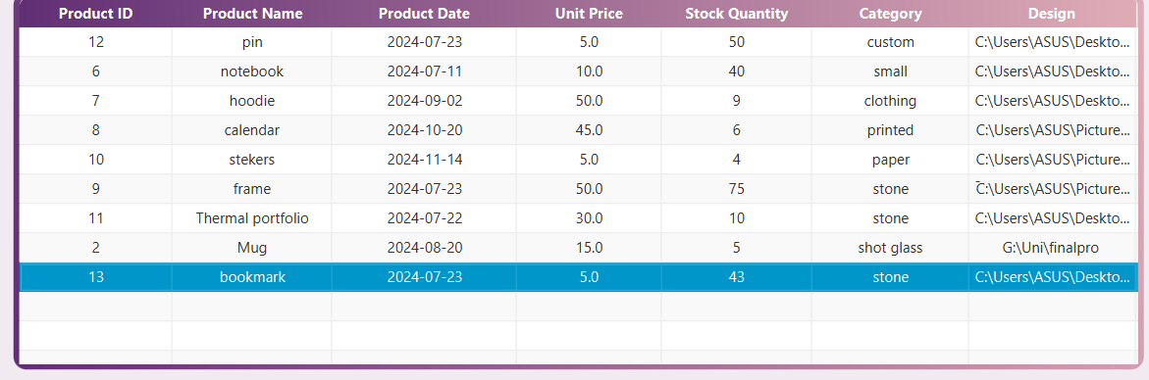

here we updated the design folder for bookmarks

If the employee attempts to enter a non-integer price, they will receive a warning message indicating the input is invalid and must be an integer.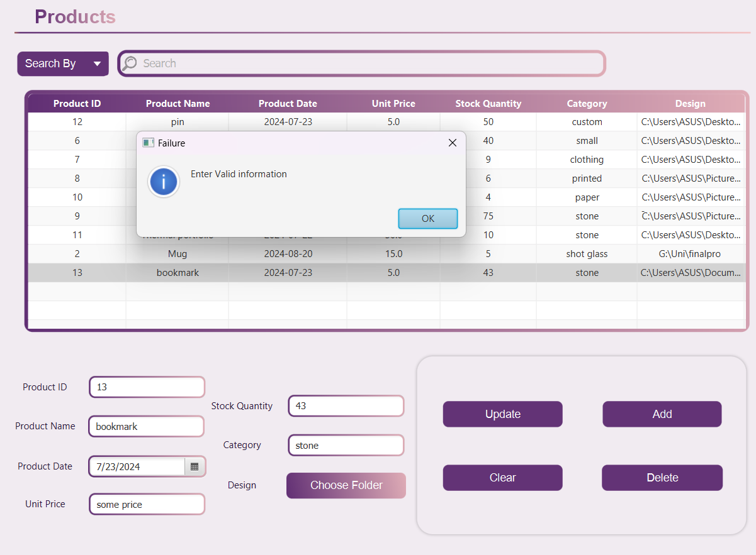

## The Employee Page

If the user's job title is "Employee," an Employee page will be displayed, showing the employee's information, which cannot be modified.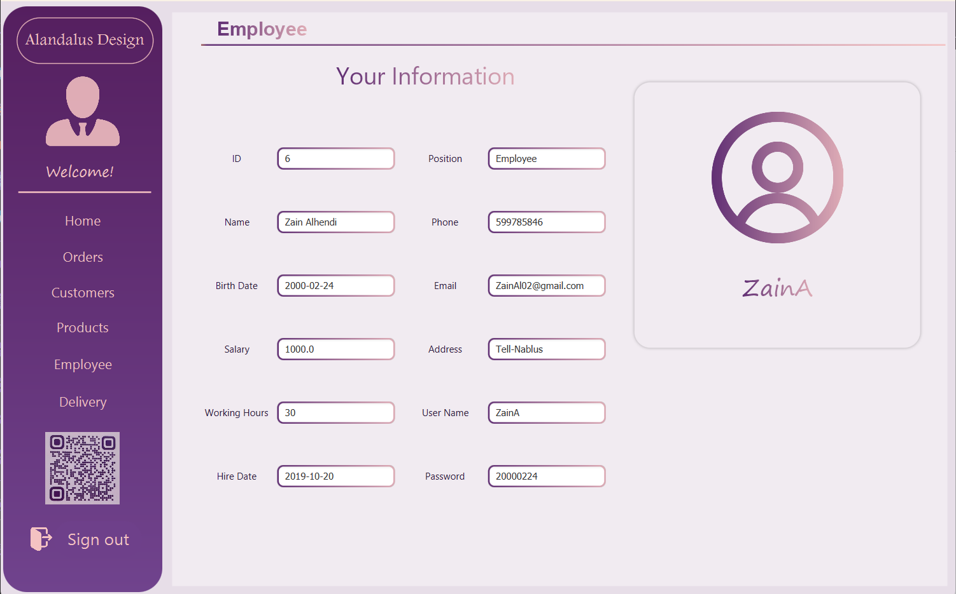

## The Manager Page

If the user's job title is "Manager," they will have access to the Employee page, where they can view the employee database, see all employee information, and modify it as needed.

The manager has the ability to **update** any employee's information.

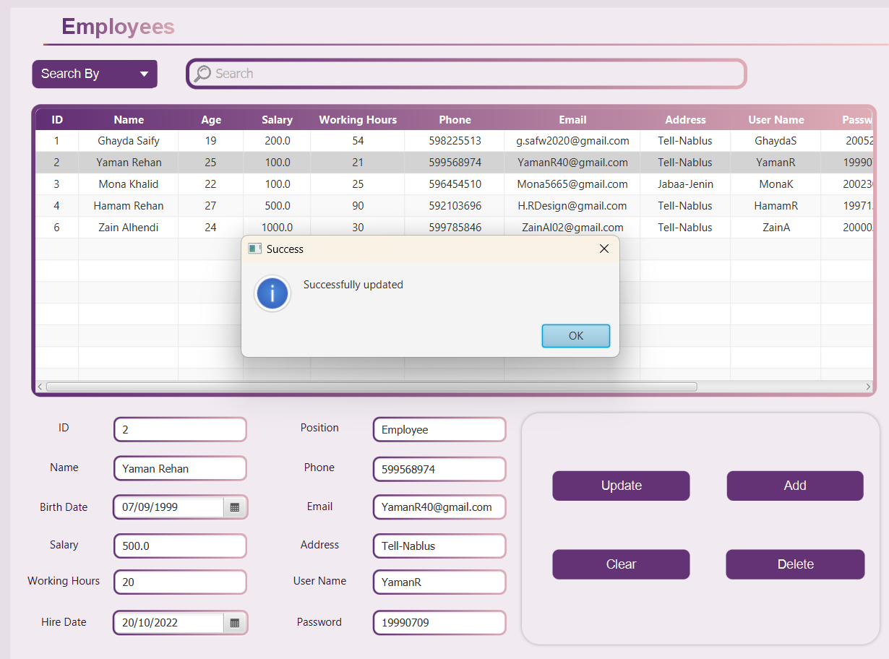

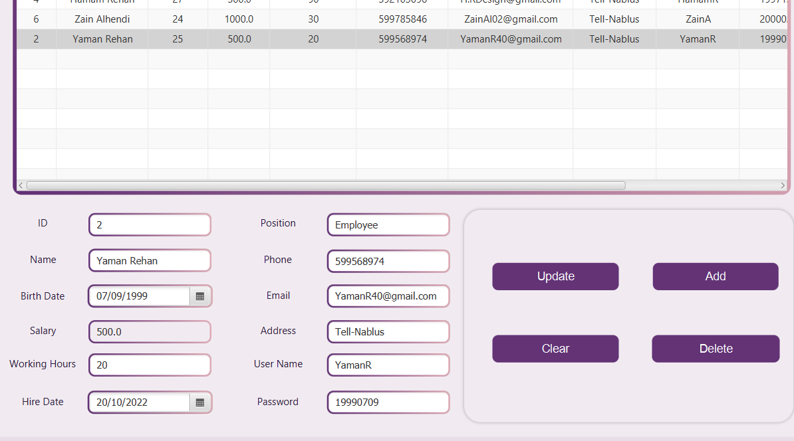

**Delete**: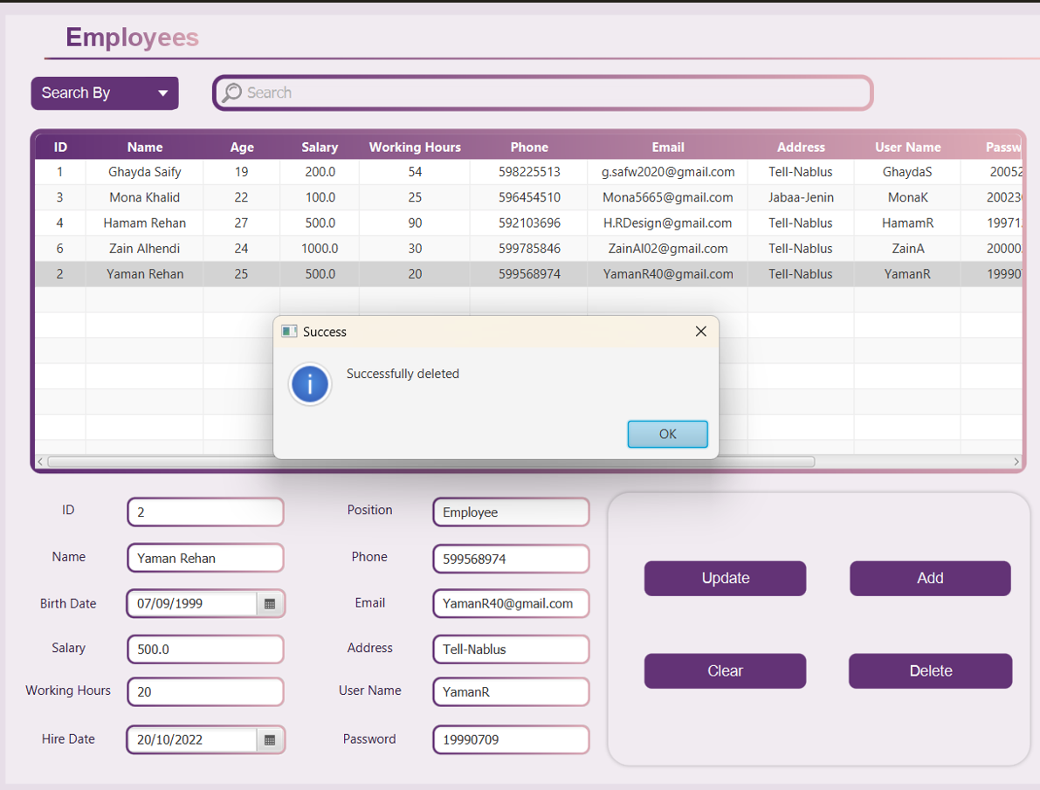  
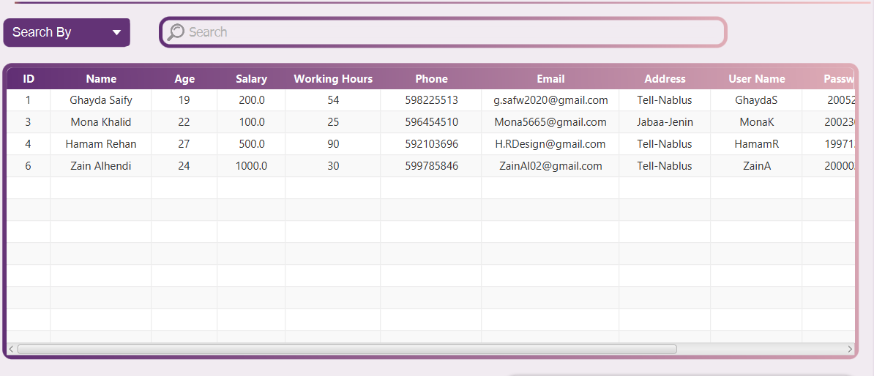

If the user tries to delete an employee record without specifying the ID, an **error** message will be generated.

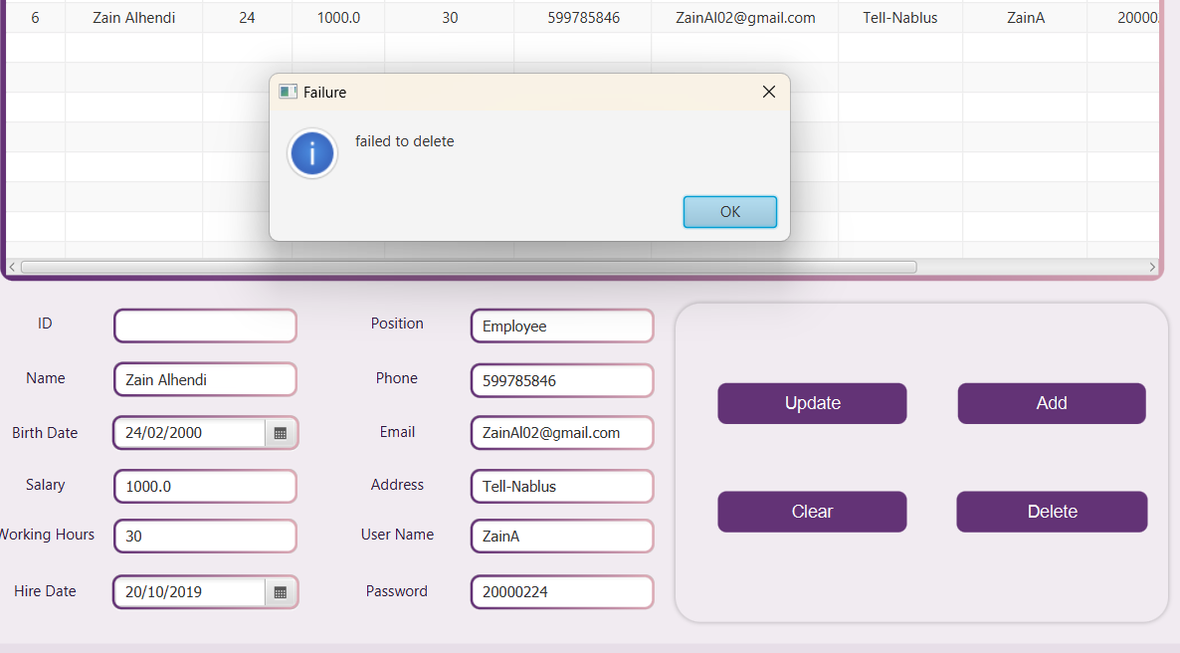

OR Update an employee record without specifying the ID.

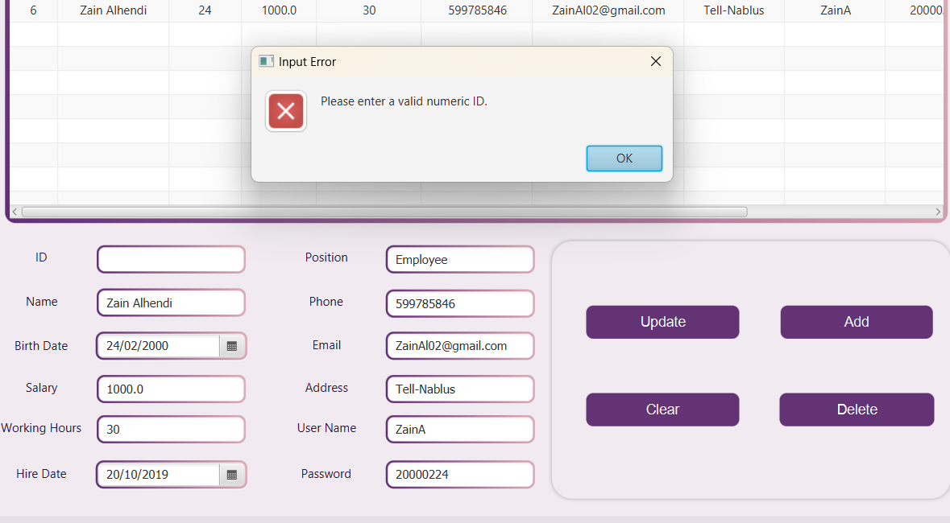

The manager can search for any employee by their ID, name, or salary to view their information in the system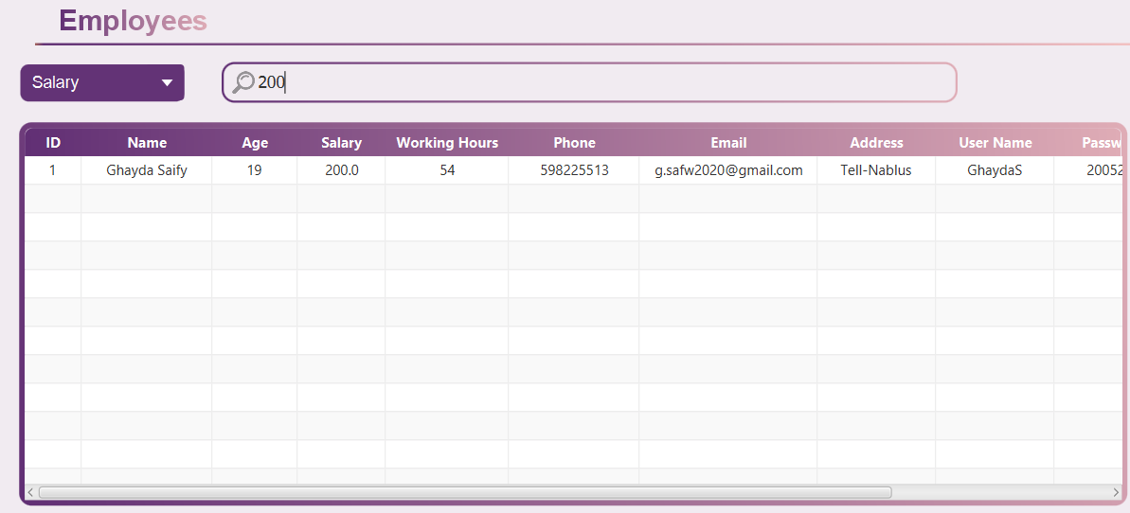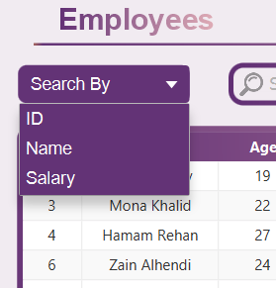

If the employee's ID, name, or salary is not found in the database, an error message will be generated, indicating that no matching record was found.

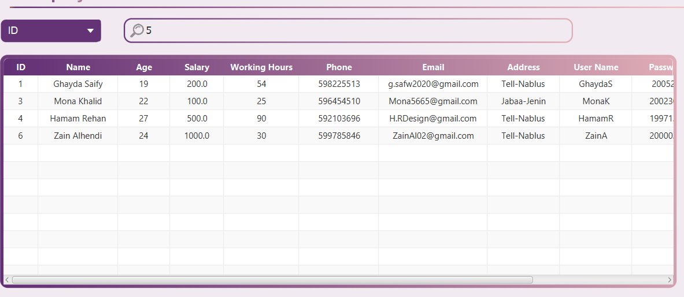

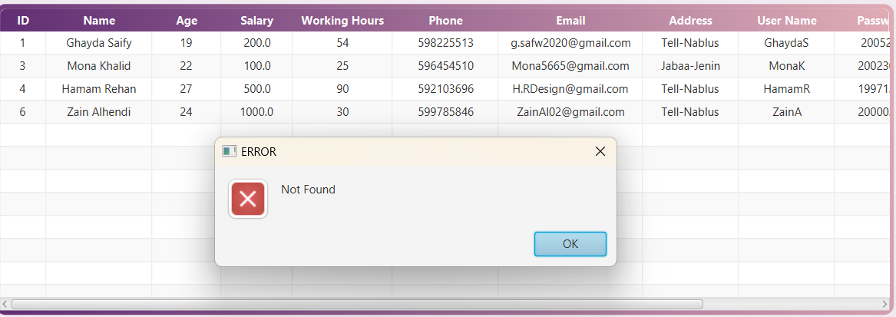

## The Delivery Page

On the delivery page, we display all the delivery information stored in the database. It includes features such as a search filter, a list of deliveries, and form fields for delivery details with options to update, add, clear, and delete delivery records. The Clear button resets all form fields, allowing the user to start fresh if they wish to enter new data or cancel the current input.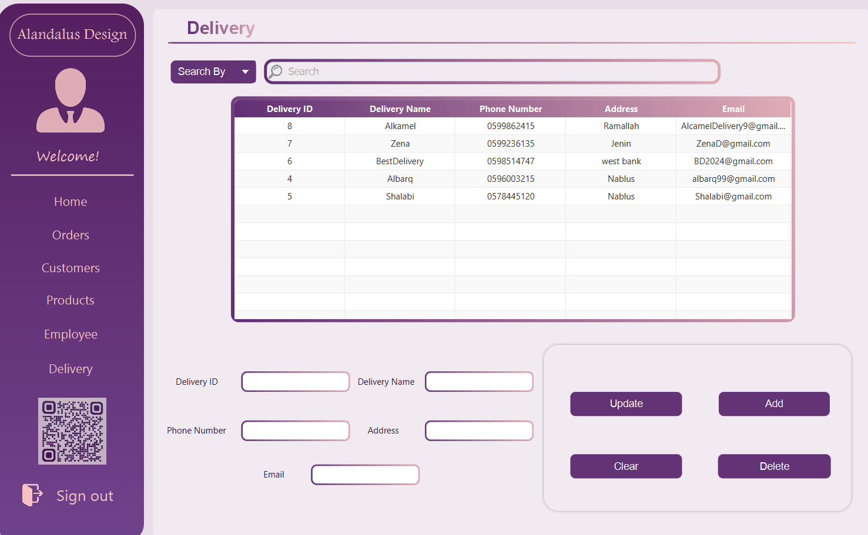

The user can add a new delivery, update delivery information, delete a record, and search for deliveries by delivery ID, name, or address. These features allow for easy management and tracking of delivery details within the system.

**Search by:**

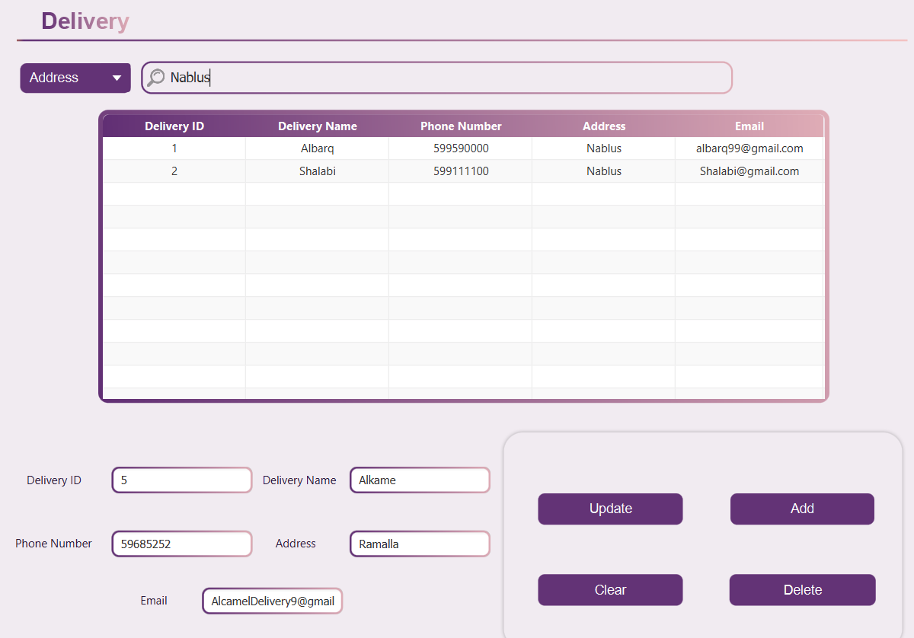

**Update:** 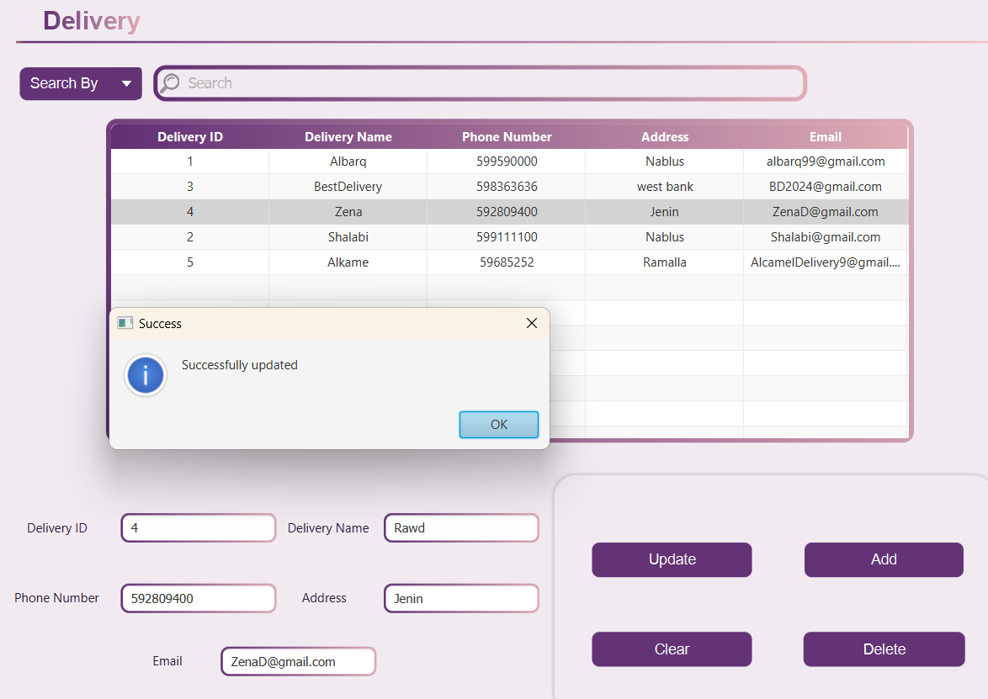

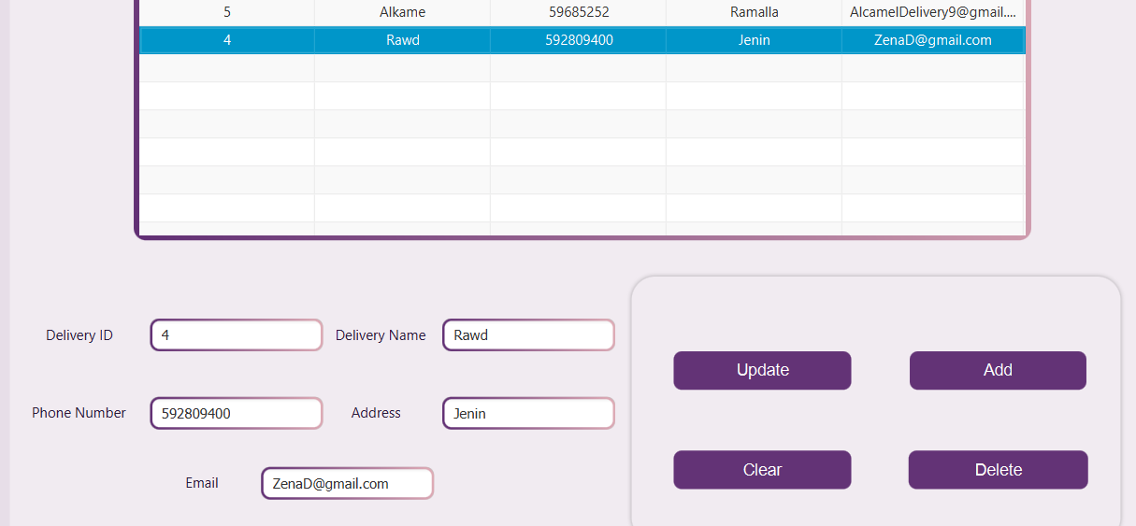

**Clear:**

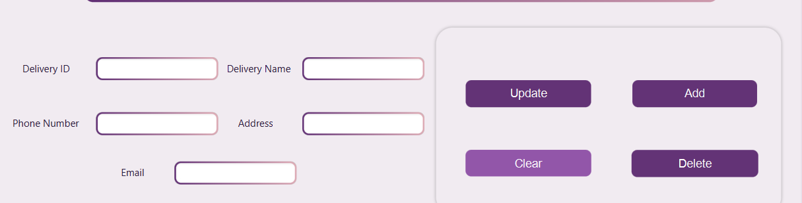

**Delete:**

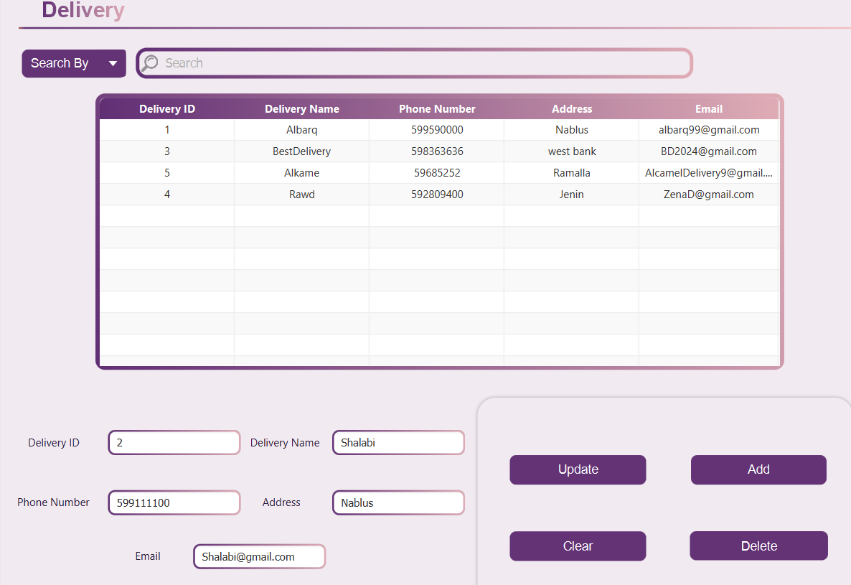

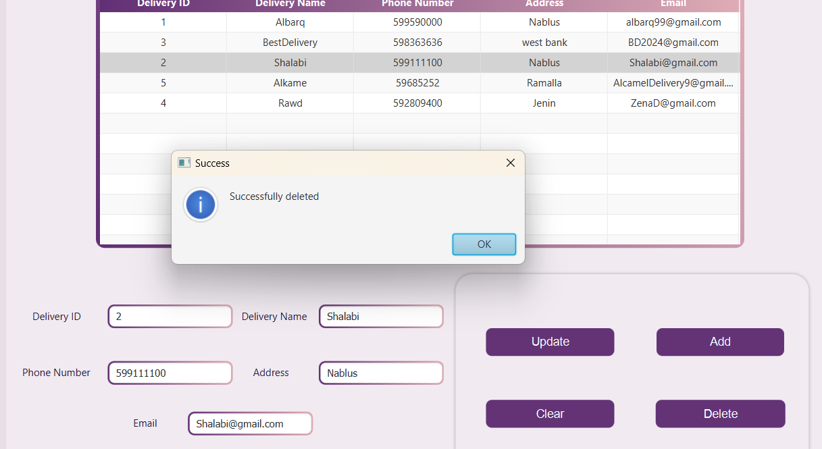

**ADD:**

**before :** 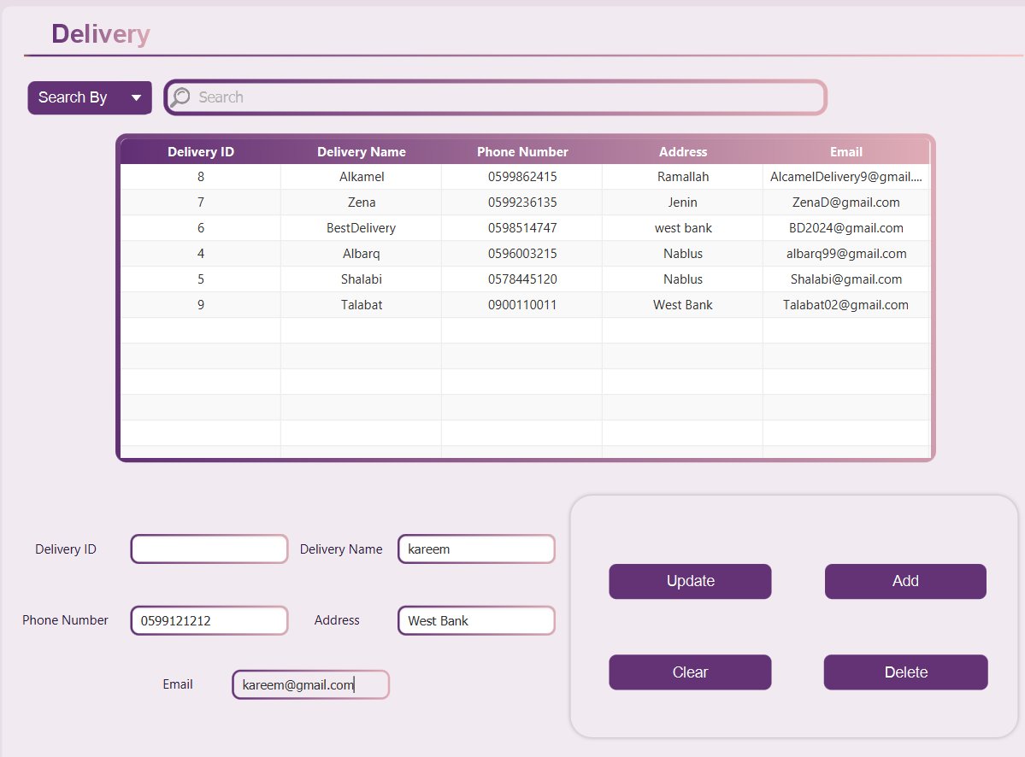

**After :** 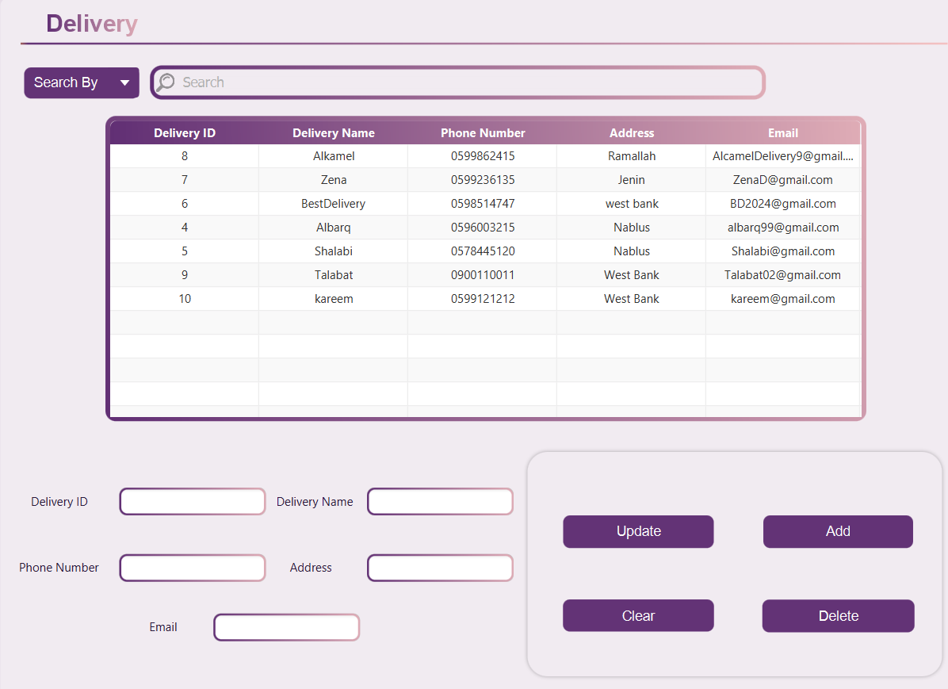

# Conclusion

The Alandalus Design Company application was developed to modernize and streamline business operations, ensuring efficient management of customer orders, product inventory, and employee performance. This comprehensive system supports a range of functionalities that facilitate secure data management, seamless order processing, and robust delivery tracking.

Throughout the project, each module was carefully designed and implemented to provide essential tools that contribute to the company's operational efficiency. The application includes user-friendly interfaces for employees and managers, allowing them to interact with customer data, employee information, product inventory, and delivery services with ease. Reports generated using JasperSoft Studio offer insights into orders, employees, and product availability, aiding in decision-making processes.

The project also incorporated features to enhance user interaction, such as responsive forms, error handling, and real-time updates. From the splash screen's engaging animation to the detailed dashboards and comprehensive search filters, every aspect was built with the user's experience in mind. Managers are given advanced capabilities to modify employee data, while employees can manage orders, ensuring that data is updated efficiently with minimal steps. Additionally, the integration of charts and QR codes enriches the application, providing intuitive access to company performance metrics and online resources.

By adhering to best practices in normalization and maintaining data consistency, the system supports scalable and secure data storage. Tools like IntelliJ IDEA, Scene Builder, JasperSoft Studio, and PostgreSQL were effectively used to create a robust application architecture.

The project demonstrated success in overcoming challenges such as complex data relationships and UI responsiveness, resulting in a system that aligns with Alandalus Design Company's commitment to delivering quality and timely services. This application stands as a valuable asset to the company, simplifying its operations and reinforcing its reputation for exceptional service.

# References

* [Dashboard Template - Realtime Colors](https://www.realtimecolors.com/dashboard?colors=09020e-fcf9fe-50247a-f4c3c3-e75967&fonts=Inter-Inter)
* [Create a Palette - Coolors](https://coolors.co/ecf8f8-cb8589-474350-36827f-ff9505)
* [icons](https://www.flaticon.com)
* Database Slides & Lectures.
* PostgreSQL Documentation (PostgreSQL: Documentation)
* StackOverFlow (searching for errors solutions)
* youtube:
* https://www.youtube.com/watch?si=SW1ViyJh_LLid5RL&v=EYFDcrKpEAI&feature=youtu.be
* [JavaFX Login Page - SceneBuilder | Netbeans - YouTube](https://www.youtube.com/watch?v=_WEoMobafoM)
* [How to connect remotely to PostgreSQL Database using pgAdmin - YouTube](https://www.youtube.com/watch?v=SRY0f_GcxKc)
* [How to setup JavaFX 11+ with IntelliJ on Windows [2022]](https://www.youtube.com/watch?v=WDaXpDtYk3E)
* [Setup IntelliJ IDEA for JavaFX & SceneBuilder and Create Your First JavaFX Application - YouTube](https://www.youtube.com/watch?v=IZCwawKILsk)
* [javafx ui - google drive ui sample - YouTube](https://www.youtube.com/watch?si=3a4deWscaT4rL1ZJ&v=8KFlL4jLt2c&feature=youtu.be)
* [Build Project Application - How to design the Login Form with (Shadow Effect) design in Java.](https://www.youtube.com/watch?v=GH2yrJUVK5o&list=PLX5hCViO2ncTl0q1tztP3nJ2swB18GU6H&index=2)
* <https://www.youtube.com/watch?si=RLXhjG77BpK_RDPO&v=pf7-zMCQlIc&feature=youtu.be>
* [JavaFX Tutorial | Login and Register Screen GUI In IntelliJ & Scene Builder With MySQL - Part 1|2](https://www.youtube.com/watch?v=DH3dWzmkT5Y&list=PL9CzlNPNQEQ4YCJkl5_4eTH-f-rvF1xps&index=2)
* [How to Set Up and Use JavaFX in IntelliJ 2024 in less than 5 mins - YouTube](https://www.youtube.com/watch?si=f4FhDgbyUbIYWypM&v=udigo_qSp_k&feature=youtu.be)
* [Setup IntelliJ IDEA for JavaFX & SceneBuilder and Create Your First JavaFX Application - YouTube](https://www.youtube.com/watch?si=UUdRfZUd66Ijbg8c&v=IZCwawKILsk&feature=youtu.be)
* <https://www.youtube.com/watch?si=g93fgwMyO4lKDkAu&v=JUae3nSGkRI&feature=youtu.be>
* [Community Edition - Jaspersoft Community](https://community.jaspersoft.com/download-jaspersoft/community-edition/)
* [Maven Repository: net.sf.jasperreports » jasperreports » 6.20.6](https://mvnrepository.com/artifact/net.sf.jasperreports/jasperreports/6.20.6)
* [XML Schema Part 2: Datatypes Second Edition](https://www.w3.org/TR/xmlschema-2/#string)
* [I can't import java.sql classes even that I have added them to the library – IDEs Support (IntelliJ Platform) | JetBrains](https://intellij-support.jetbrains.com/hc/en-us/community/posts/360003378559-I-can-t-import-java-sql-classes-even-that-I-have-added-them-to-the-library)
* [Create a PostgreSQL data source for Heroku Postgres without SSL validation | IntelliJ IDEA Documentation](https://www.jetbrains.com/help/idea/how-to-connect-to-heroku-postgres.html)
* [JavaFX - Background Thread for SQL Query - Stack Overflow](https://stackoverflow.com/questions/14878788/javafx-background-thread-for-sql-query)
* [Create a PostgreSQL data source for Heroku Postgres without SSL validation | IntelliJ IDEA Documentation](https://www.jetbrains.com/help/idea/how-to-connect-to-heroku-postgres.html)
* [Database Tools and SQL | IntelliJ IDEA Documentation](https://www.jetbrains.com/help/idea/relational-databases.html#first-steps)
* [Glossary for the database management functionality | IntelliJ IDEA Documentation](https://www.jetbrains.com/help/idea/glossary-database-tools-and-sql.html)
* [PostgreSQL | IntelliJ IDEA Documentation](https://www.jetbrains.com/help/idea/postgresql.html)
* [java - JavaFX CSS WARNING: CSS Error parsing file : ... : Expected LBRACE at - Stack Overflow](https://stackoverflow.com/questions/28973873/javafx-css-warning-css-error-parsing-file-expected-lbrace-at)
* <https://www.geeksforgeeks.org/introduction-to-jdbc/>
* [PostgreSQL Tutorial](https://www.w3schools.com/postgresql/index.php)
* [Free Logo Maker - Get Custom Logo Designs in Minutes | Looka](https://looka.com/editor/201364151)